Travel Report - Trip Across the Great Central Rd

Part One Days 1-4 Perth to Yulara 2116Kms

Day 1 - Perth to Menzies 751Kms

We left Perth in time to catch the peak hour traffic, so took a while to clear the city and get moving freely.
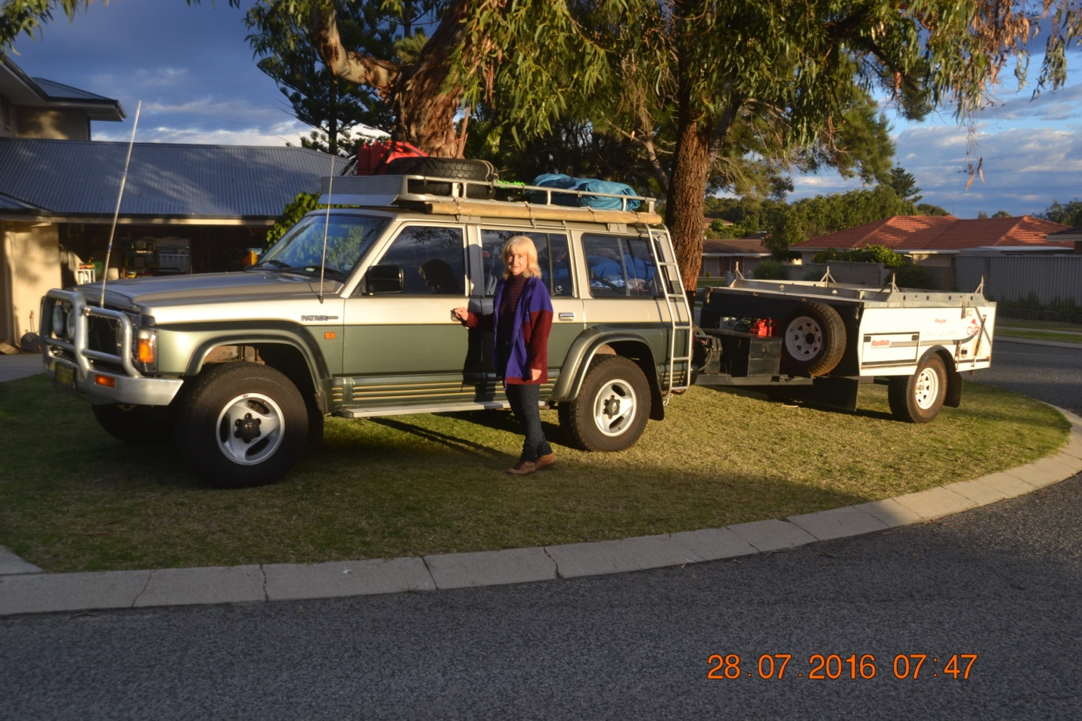
Ready to roll
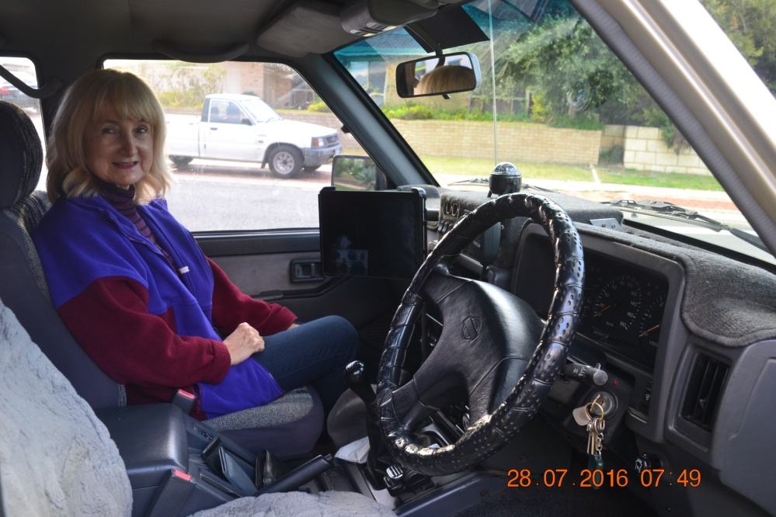

The navigator sitting in the office.

The RAM mount attached to the grab rail allowed the iPad which served as our GPS with the Hema 4WD Maps app to be easily seen by us both.

The journey through the farming belt saw crops in strong growth (wheat and canola) and the land looking well watered after much more winter rainfall than previous years. It took a while to get into the swing of extended travel. I adopt an approach of what I refer to as "relaxed concentration," something I find essential for alert driving over long distances. I had to fight feelings of drowsiness at times, especially during the morning, but by the afternoon and early evening felt in the swing of things and travelling Ok. We wanted to get as much of the blacktop out of the way on day one as we could, and made it as far as Menzies after some night driving.

Day 2 - Menzies to Tjukayirla 538Kms

We knocked off the rest of the blacktop section through Leonora and Laverton and on to the start of the Great Central Rd.
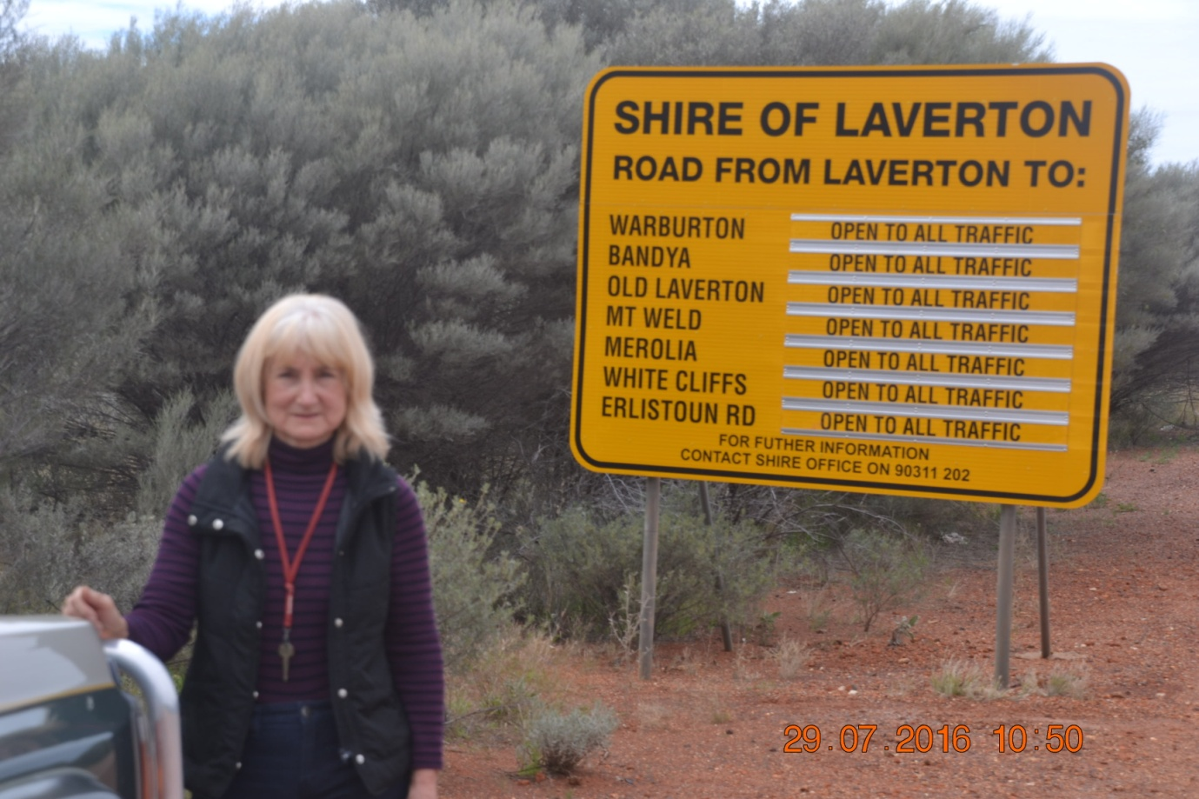

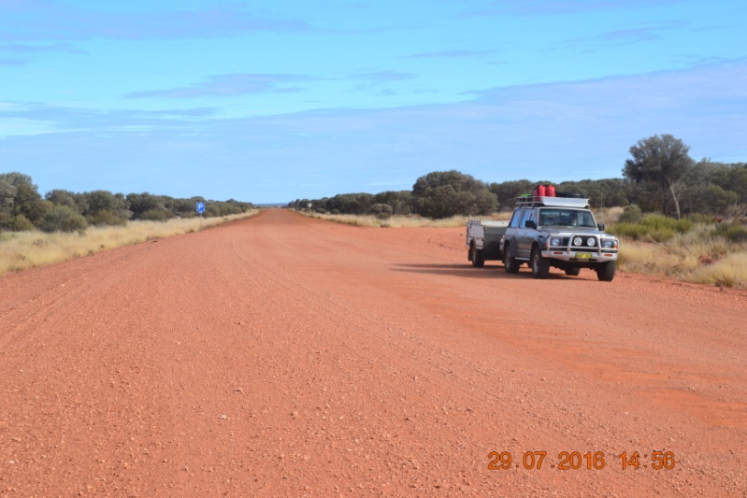
The recent wet weather had left the road in poor condition, and there were several road crews out doing maintenance. The first day on the GCR wasn't too bad. Our cruising speed was around 80Km/h, and conditions were not too rough. Dust wasn't too bad at this stage either.

The desert was much greener than anticipated, again as a result of the higher recent rainfall. Lots of abandoned vehicles littering the roadside. Concentration much better. We briefly spotted one camel, but had no other wildlife encounters.

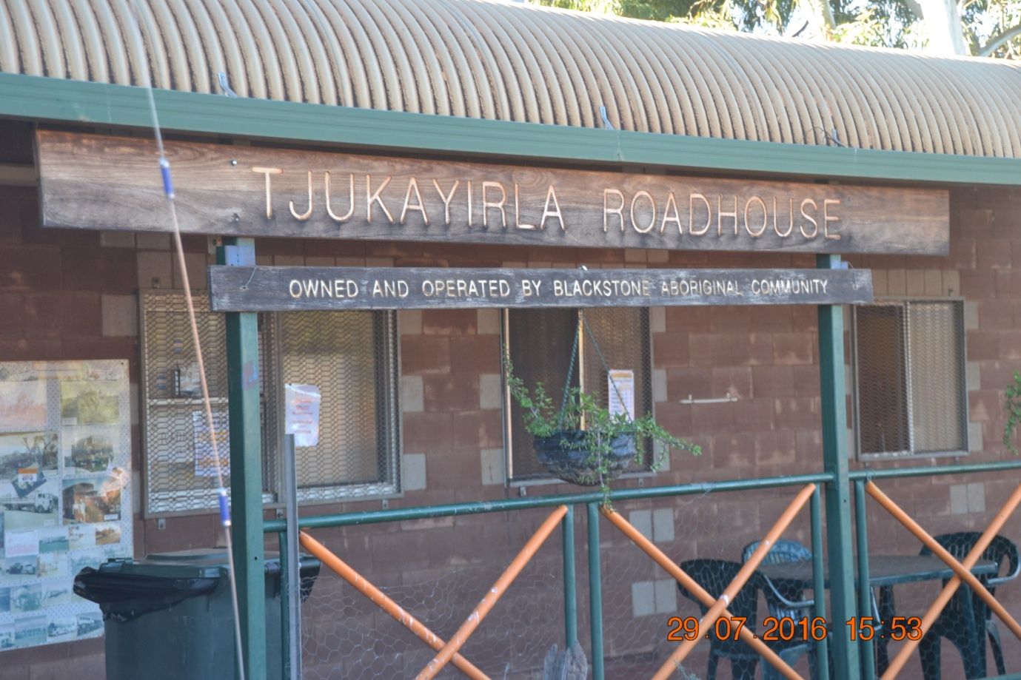

Day 3 - Tjukayirla to Warakurna 479Kms

The road became much rougher the further east we travelled.
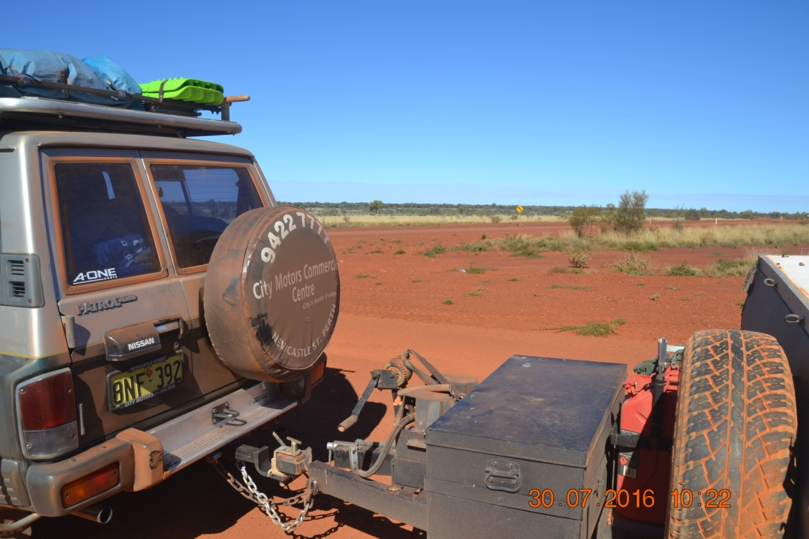
Red dust was also becoming an issue and starting to filter into everything. Speeds became lower as conditions deteriorated.

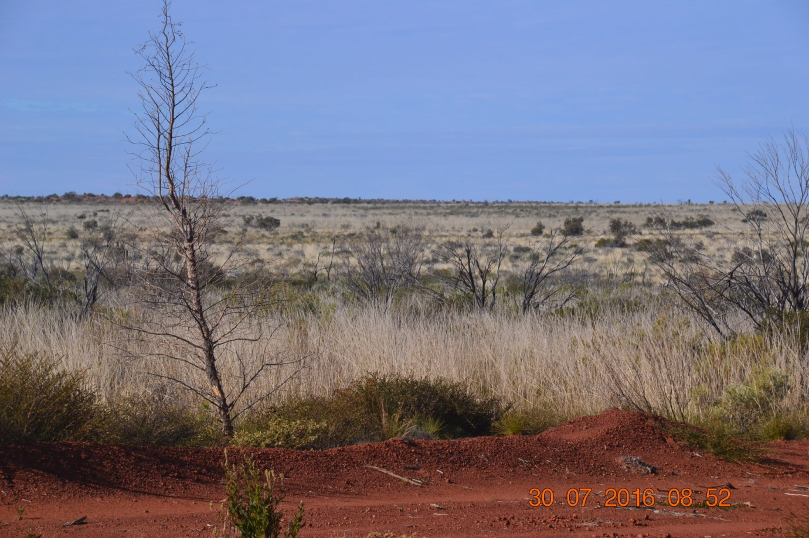
The desert was in vibrant growth, particularly the Spinifex, which had strong light coloured stalks extending from the clumps. The landscape though was generally flat and featureless, with plenty of old dead vehicles lying about. Below is an old tractor dumped at one of the roadside stops.
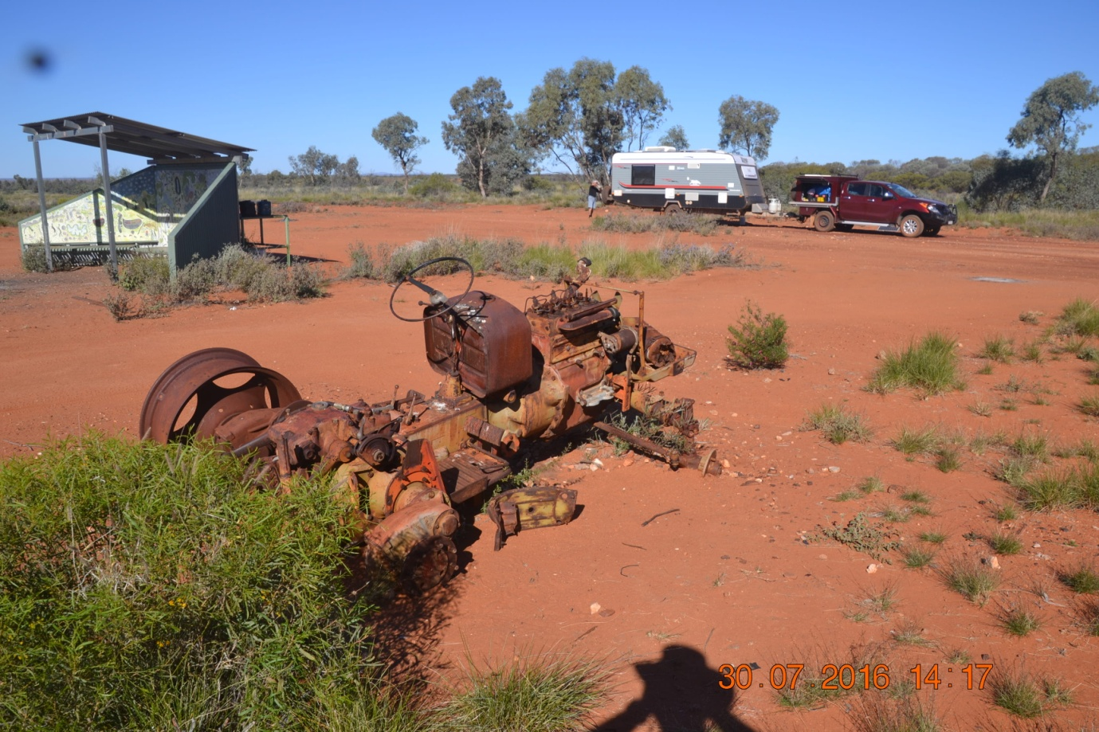

The Patrol and trailer were travelling well. We were astounded to run into a Police road block in the middle of nowhere between Warburton and Warakurna. Ostensibly a licence and drink driving check, but we felt they were looking for something or someone, because there was quite a contingent of vehicles and personnel, much more than the very light traffic volumes would justify.

Day 4 - Warakurna to Yulara 348Kms

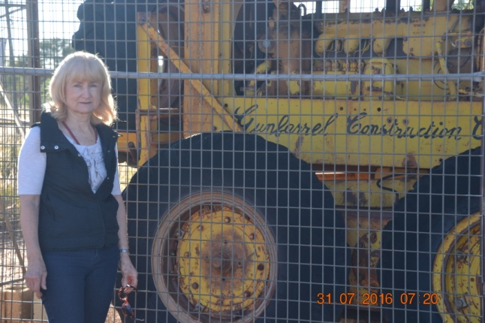
Before leaving Warakurna we visited the Giles Weather Station (most remote in Australia), saw the daily weather balloon ascending after its release, and saw Len Beadell's famous grader and other memorabilia.
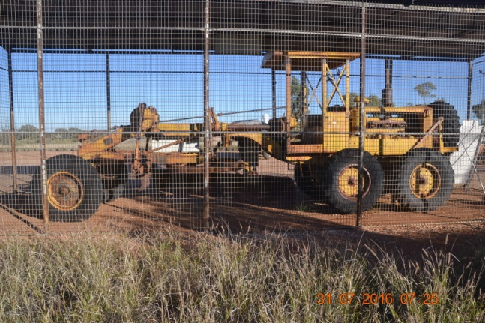

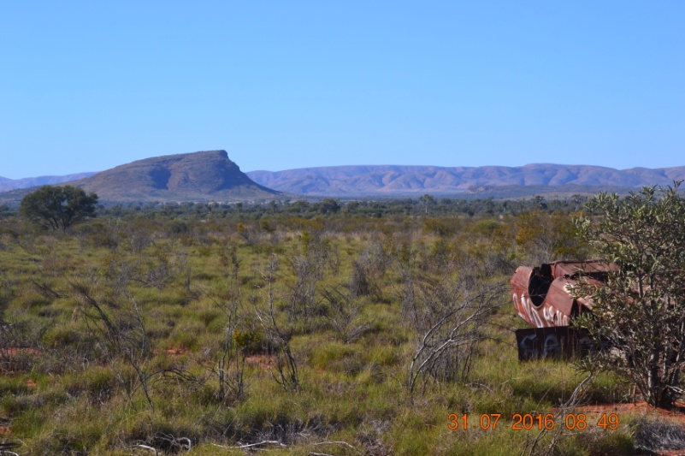
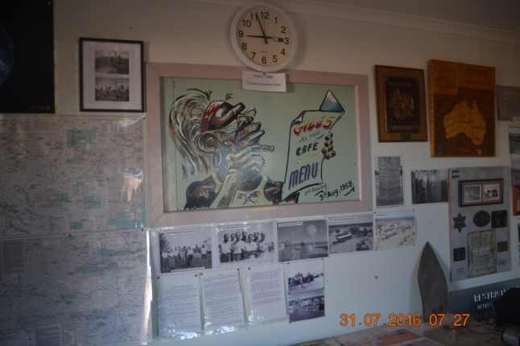
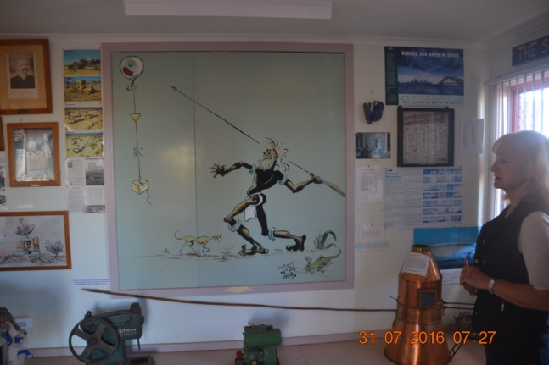
The road became progressively worse and our speed lower, but the country more interesting as we approached Docker River, with the Bloods Range and Petermann Range providing a change in vista from the generally flat and featureless landscape of the previous 2 days.
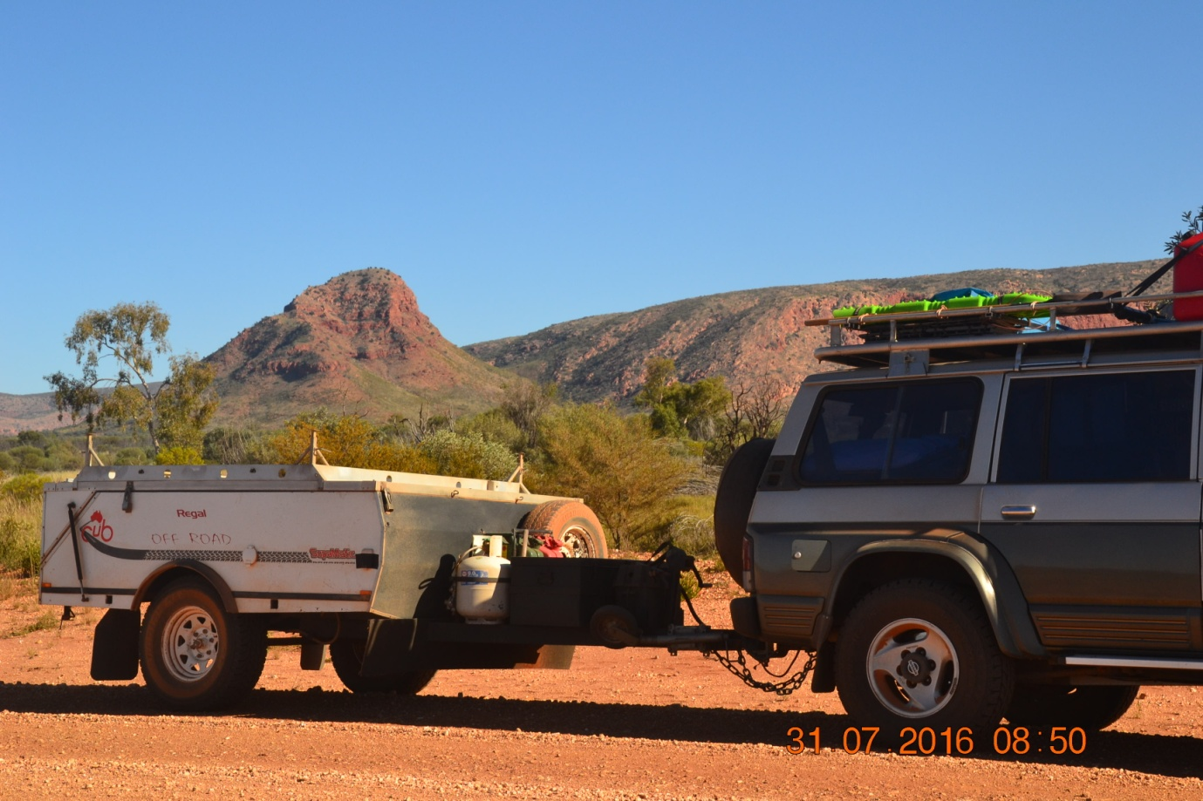
After Docker River the ravages of the previous rainfall period were still very apparent on the road.
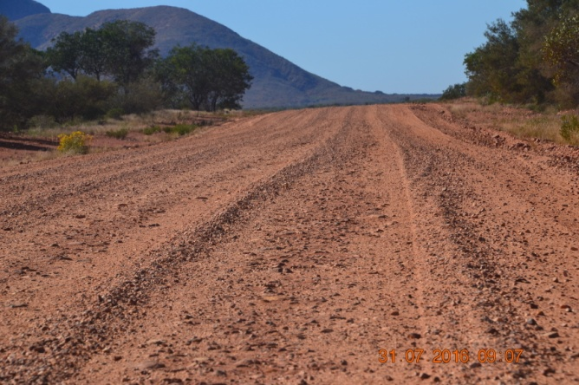
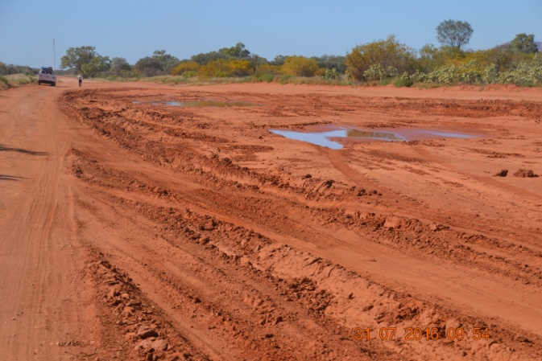
Not just long ruts cut in what had previously been obviously soft roads after rain of the previous days, but huge bog holes with deep vehicle tracks in them, witness to the struggle vehicles had to get through them during the previous wet.
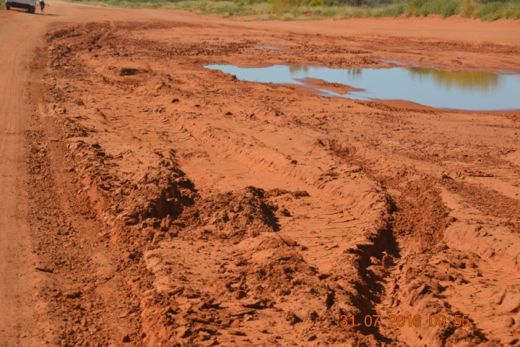
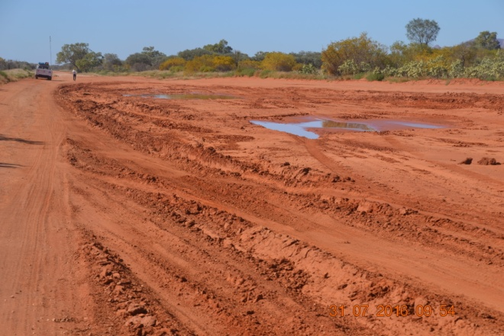
Even though roads are closed when conditions deteriorate, our guess was not everyone had adhered to the road closures. With some bog holes I expected to see the rooves of vehicles still buried in them.

We visited Lassiter's Cave and had a look around there. Not much to see but an interesting piece of Australian history.
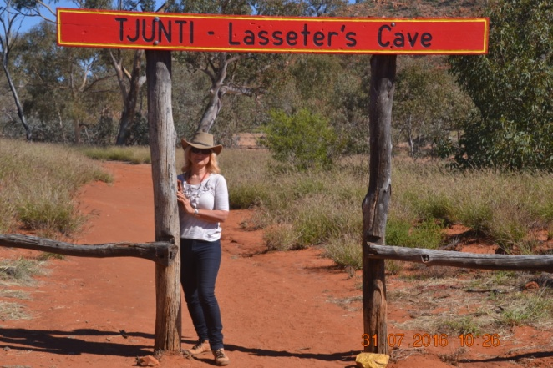
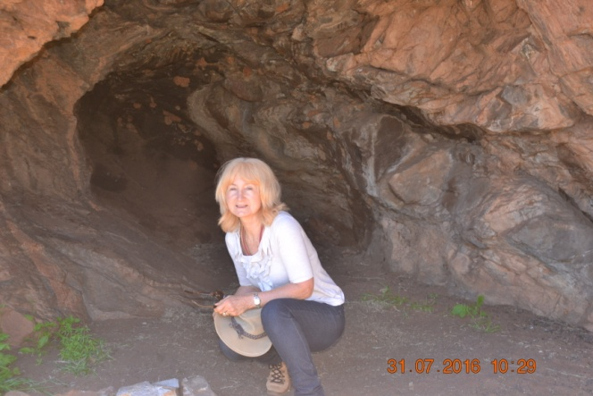
Approaching Kata Tjuta
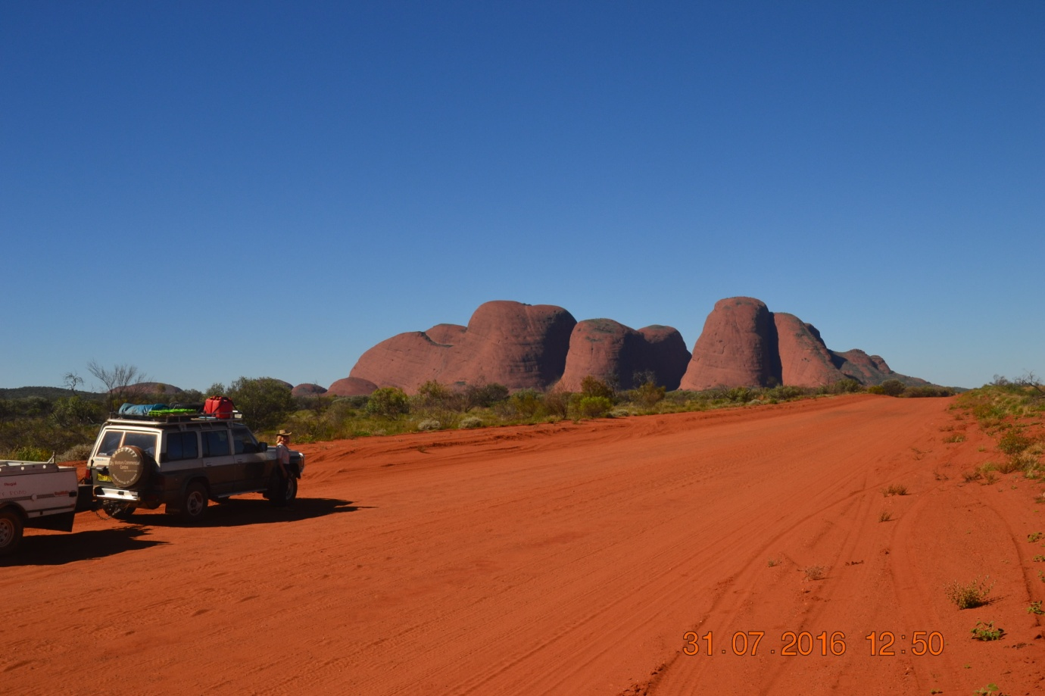
Kata Tjuta (the Olgas) presents an very different profile as you approach. The road eventually reverts to blacktop as you near the area, bringing to an end the rough and unmaintained road we had been travelling. We enjoyed a break from the red dust and ruts for the next two days.

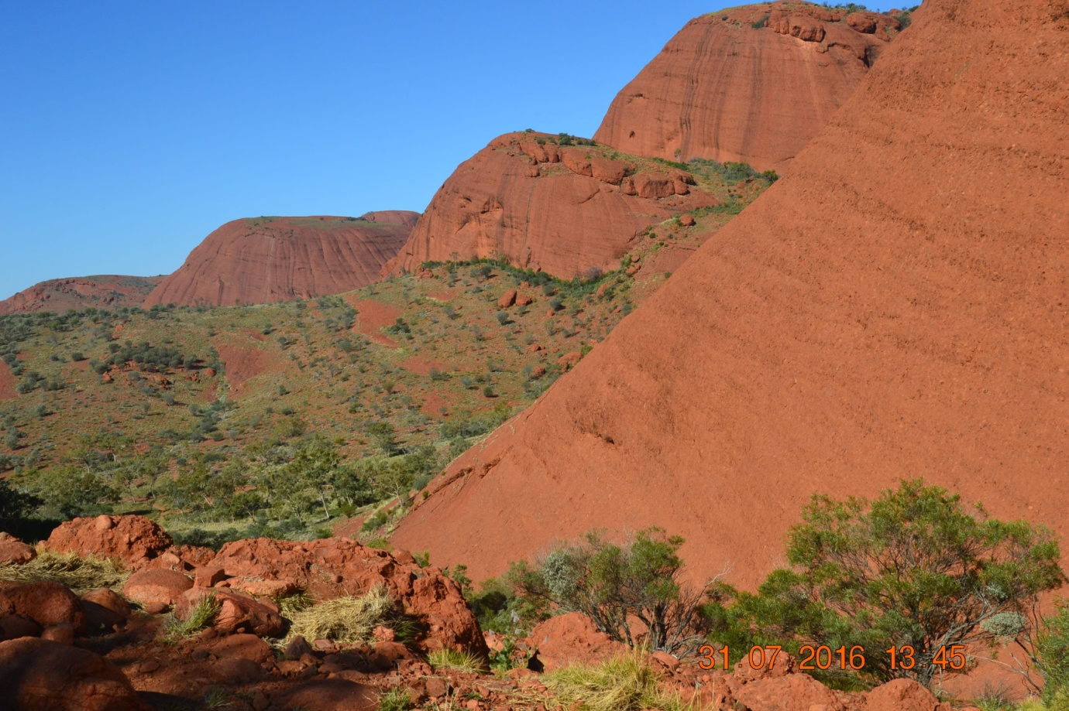
We stopped at Kata Tjuta, and walked into the Valley of the Winds. Even though conditions were calm outside the area, as you get into the valley the wind picks up, generated by a local phenomena that produces its own wind pattern due to shape of the domes.
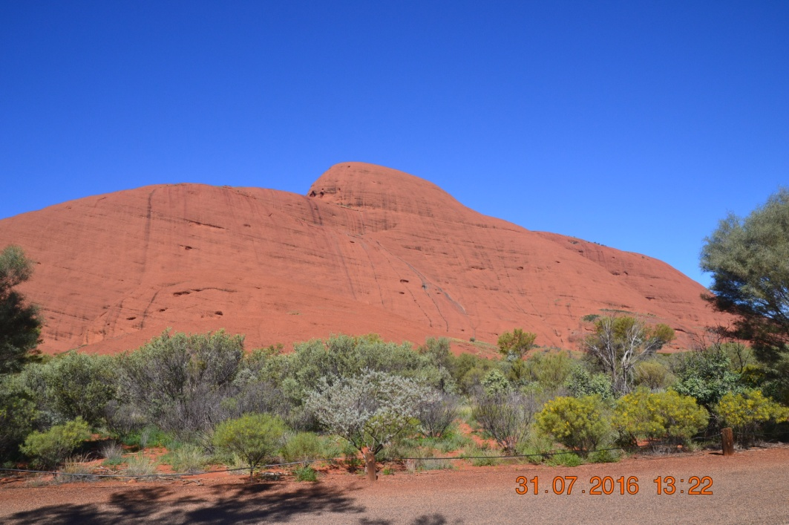
We think we found Australia's next submarine, (they don't need to spend billions building them, just find a way to transport it to the coast).

Interesting texture and shape to the domes.

We then travelled on to Yulara to set up camp for the next two nights while we visited Uluru.

Day 5 - Uluru

One of our objectives in making the journey was to spend a day at Uluru, taking in as much of its variations in shape, texture and colour as we could. We walked around several parts of it, drove around it and photographed it from many different angles, and then stopped at the sunset viewing area to watch the colour changes as the light diminished with the sunset. Hope you enjoy some of the photos.
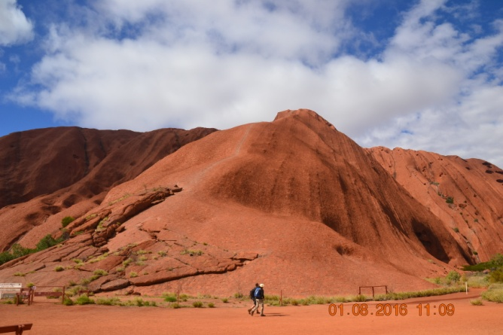
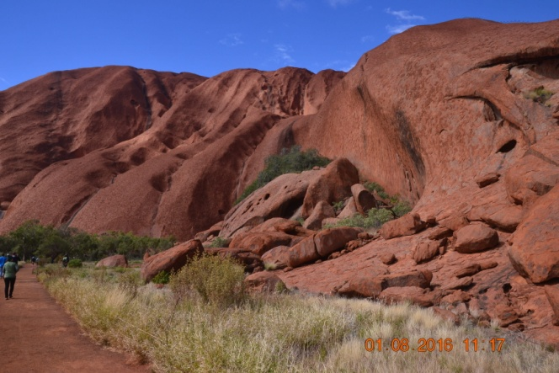
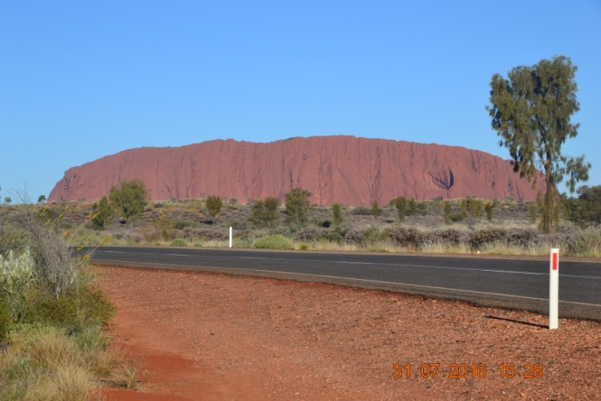
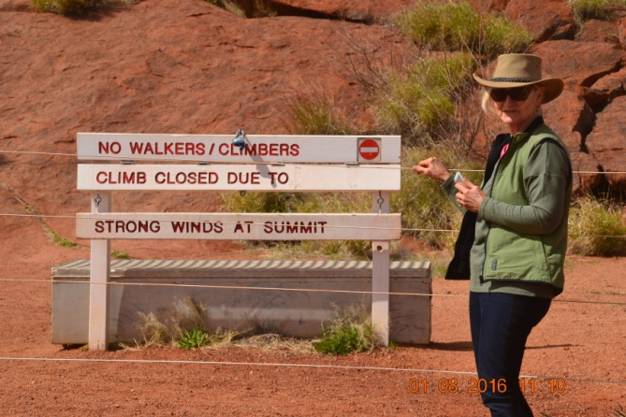
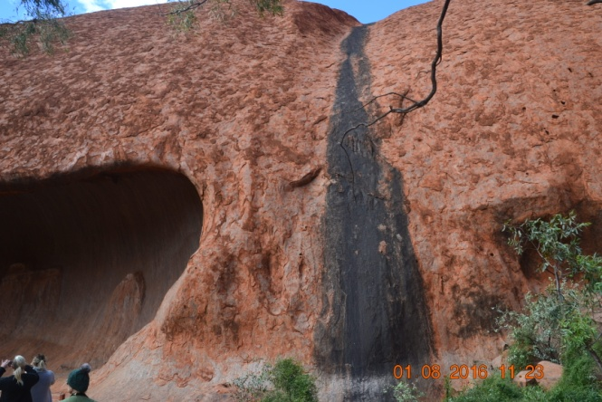
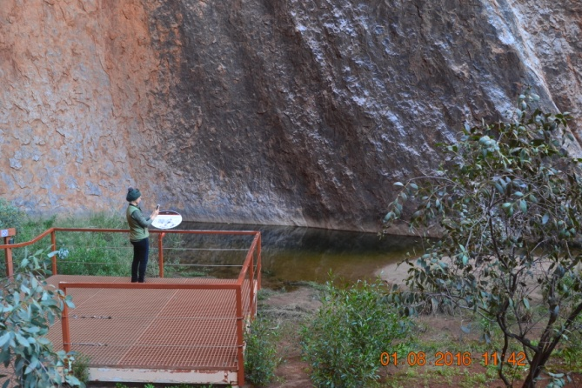

Even though Uluru dominates the landscape, Kata Tjuta is higher, and presents an eerie shape in the distance.

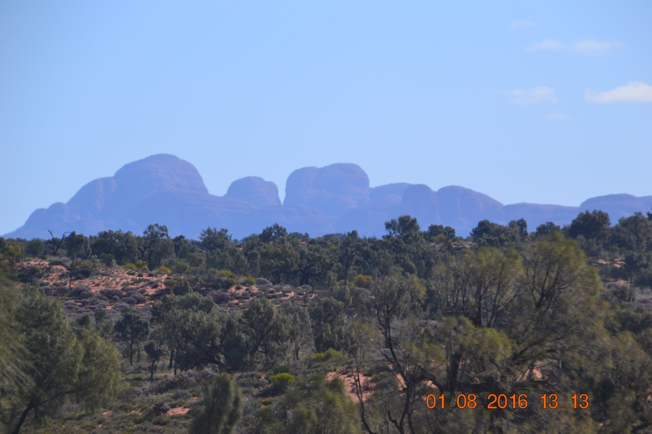
The colour of Uluru changed dramatically depending on the light conditions

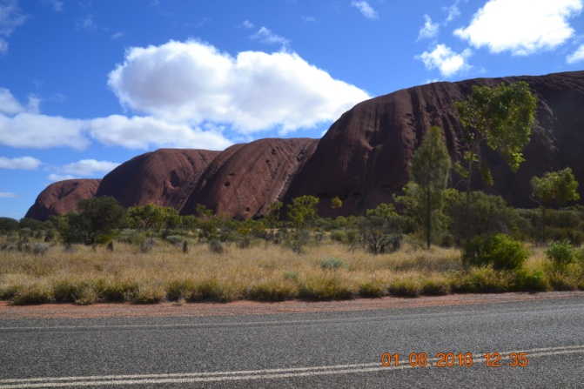
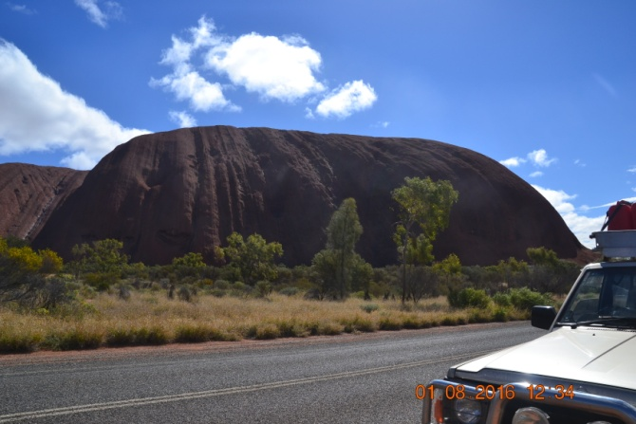
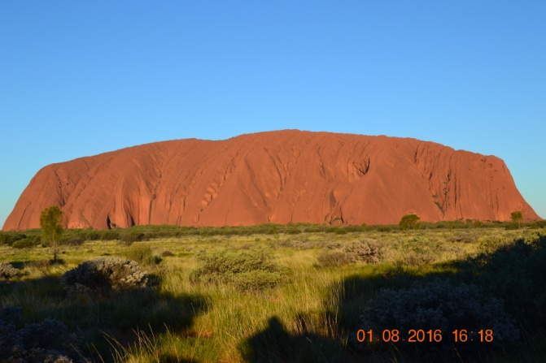
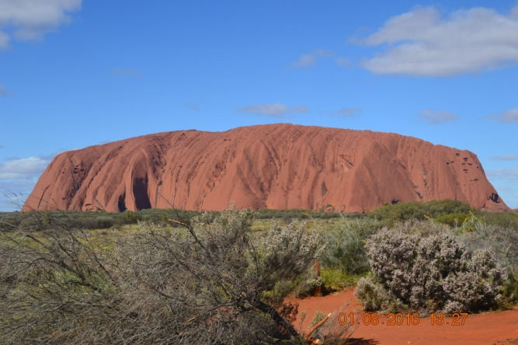
Here are some of the photos taken as the light fell, taken from the sunset viewing area.
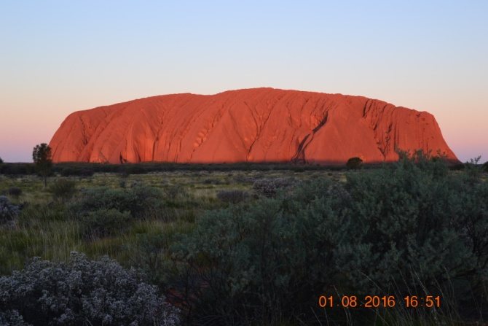
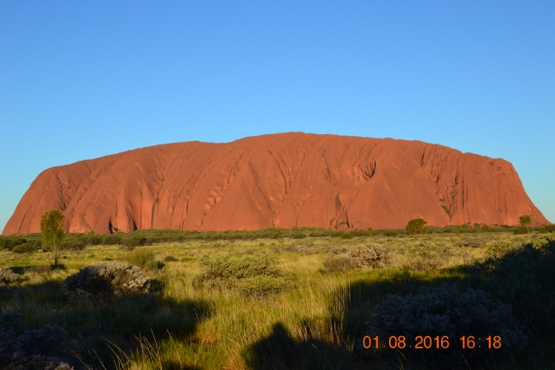
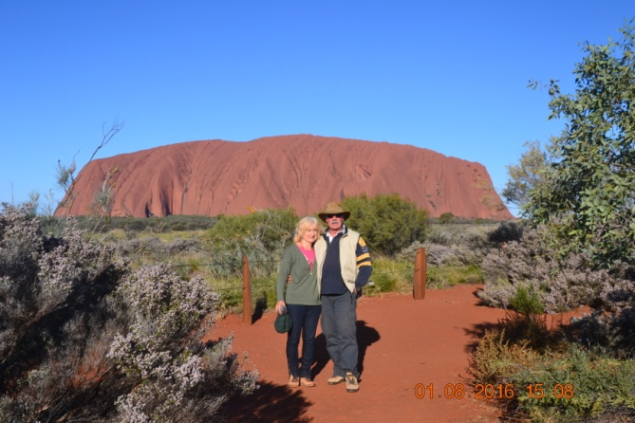
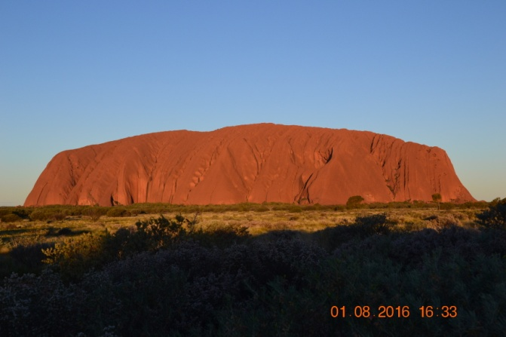
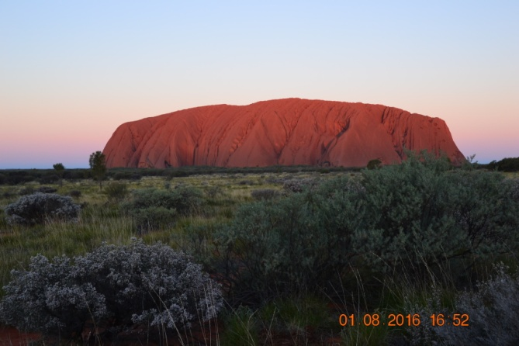
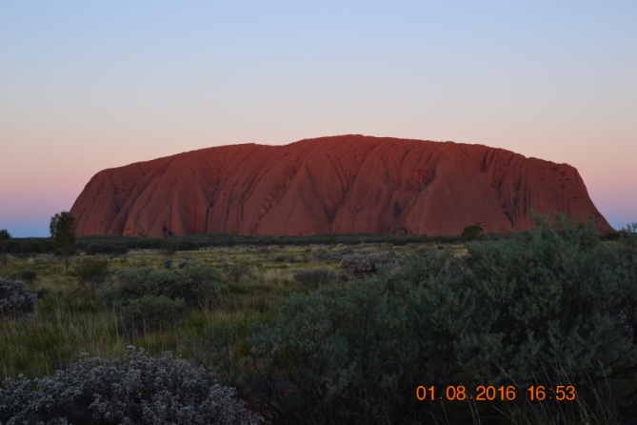

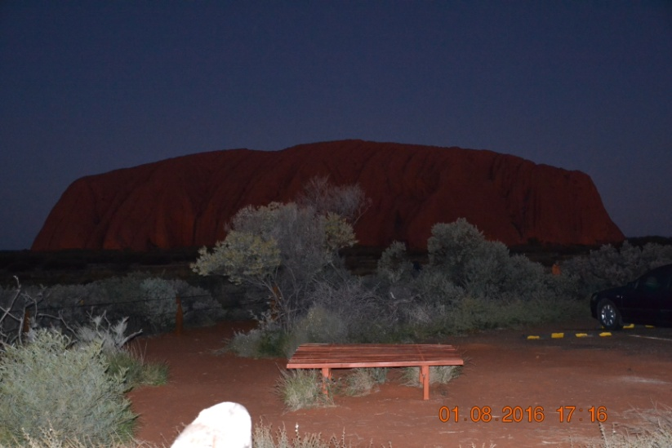
Weather conditions stayed fine but turned bitterly cold that evening at Yulara, with a high pressure cell moving in below the continent and covering much of the country, drawing up freezing cold winds from the Southern Ocean. Our hands were frozen and we had difficulty packing up the trailer to move on the following morning it was so cold.

They certainly know they have a captive public at Yulara. Camp ground fees were virtually twice anywhere else we stayed, and of course they charge park fees on top of that just to move in and out of the area. Hard not to leave the area feeling exploited, even though it was well worth visiting.

Days 6 to 8 - Yulara to Alice Springs 707Kms

This section took in Kings Canyon, the Mereenie Loop, and the West MacDonnell Ranges and associated gorges on the way to Alice Springs. You start to get into country that has ancient decaying mountains in places similar to parts of the Pilbara. We visited a selection of gorges and springs, but by no means all of them. As someone once remarked, visiting all the gorges in Australia is a bit like visiting all the cathedrals in Europe!

One thing that is hard to comprehend until you see them is the extent of the mountain ranges in the both the NT and SA. Both the MacDonnell Ranges and the Flinders Ranges are vastly more extensive than the impression you get looking at a map.

Day 6 - Yulara to Kings Canyon - 326Kms

This is a sealed road section that takes in the loop from Yulara to Kathleen Springs and Kings Canyon. On the way to Kings Canyon there is a very strange flat topped mound that comes into view (Mount Connor).
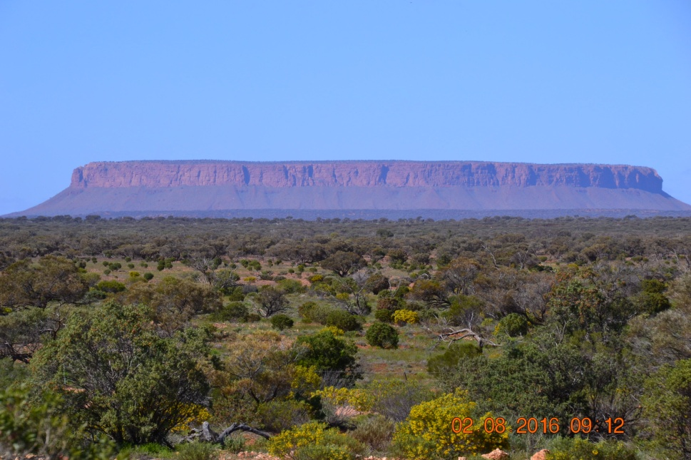

It reminds you just what an ancient landscape you are travelling through. The top of it is completely flat with sloping sides made up of debris that nature has gradually worn down from the hard centre.

We stopped and walked in to both Kathleen Springs and Kings Canyon, and also saw some interesting wildlife. A dingo came and checked us out at one stop, and we also came across some wild brumbies.
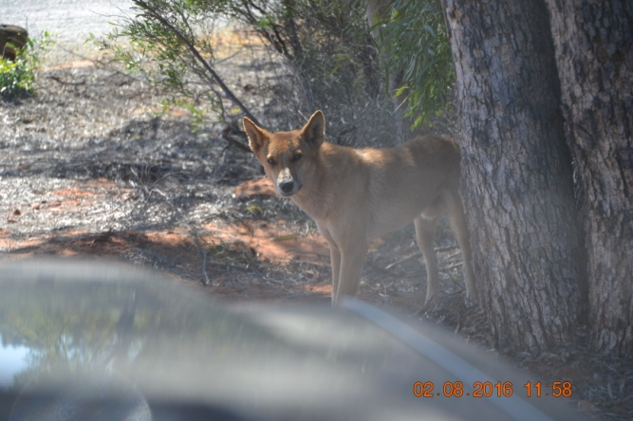
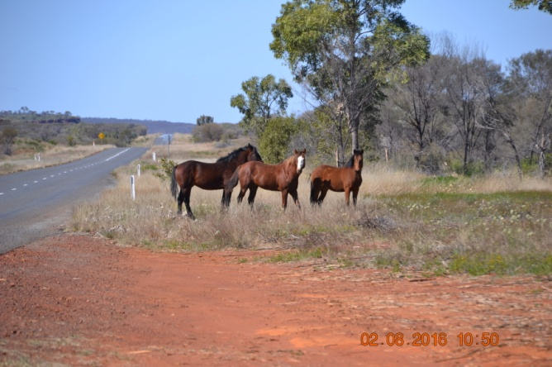
Kathleen Springs has a reliable water source and in the past was used for cattle mustering.
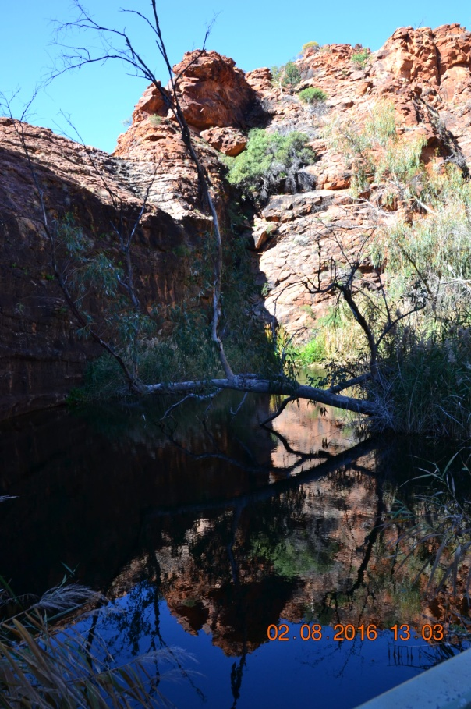
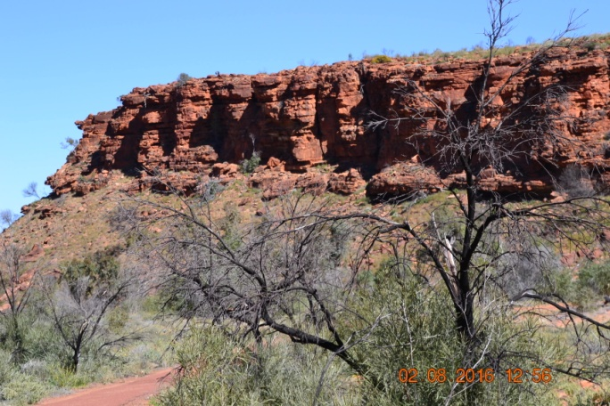
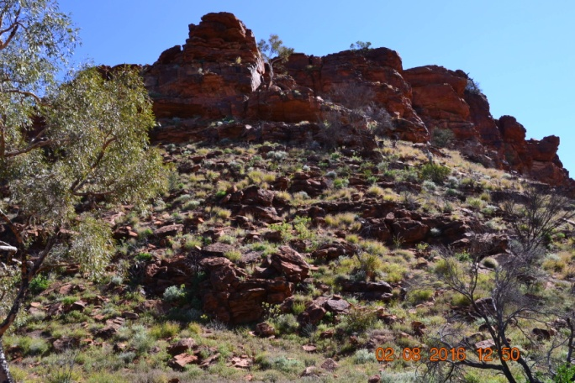

The spring is at the top of the gorge, and it is a well worth while walk.

Kings Canyon has equally impressive natural features, and we walked in to the base of the canyon before continuing and setting up camp at the local campground.
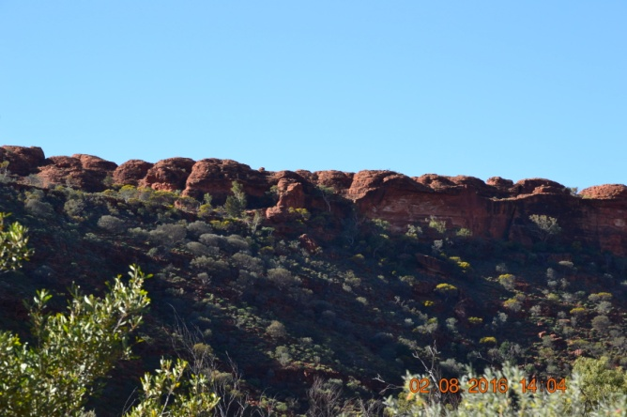
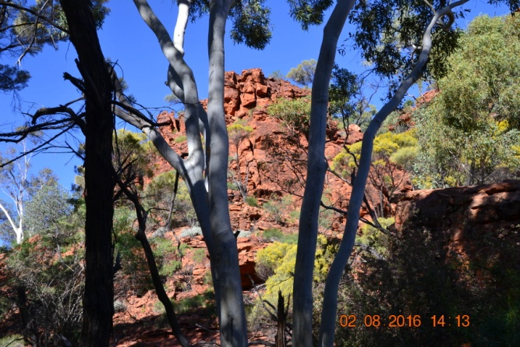
We constantly had the strong feeling of similarity with our trip through the Pilbara and visit to the Karijini gorges a couple of years ago.

Day 7 - Kings Canyon to Alice Springs 381Kms

This section takes in the very rough and unsealed section of the Mereenie Loop and then the wonderful journey through the West MacDonnell Ranges. We opted to take the more scenic option through the West MacDonnells rather than travel through Hermannsburg.

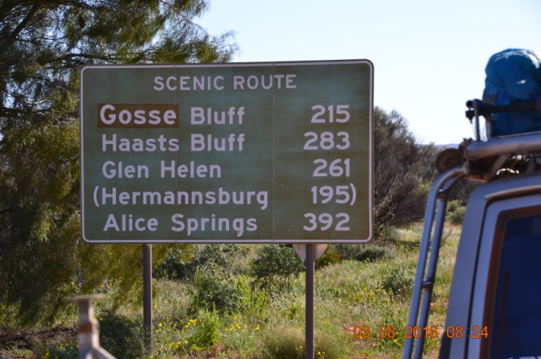
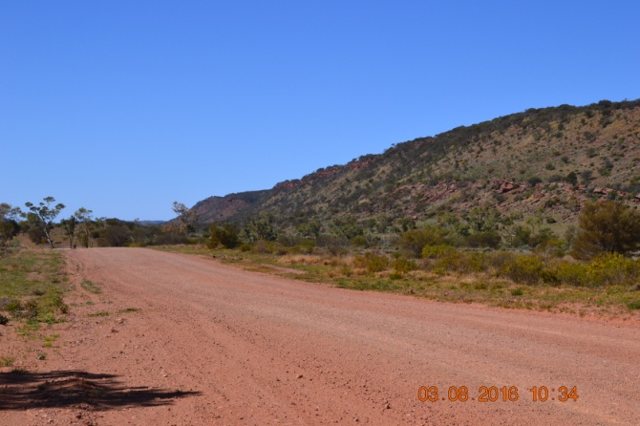
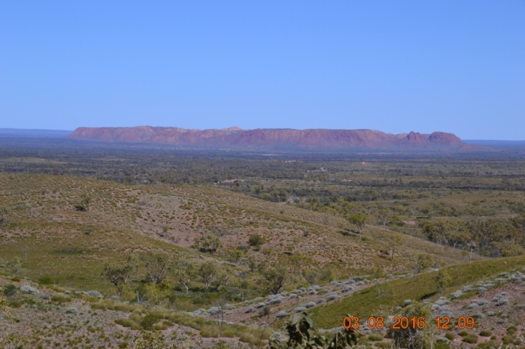
The unsealed road was very rough in places, again showing signs of recent deterioration in wet weather, with lots of rough wash-aways that come without warning. Some great views.
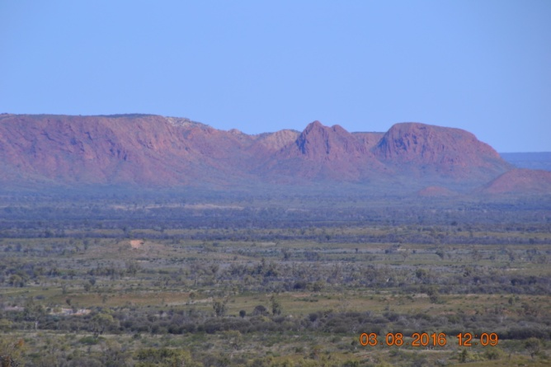

Lower tyre pressures and slower travel is the key to this section, and we covered it without incident. Back on the blacktop we made better progress, stopping first at Glen Helen Gorge.
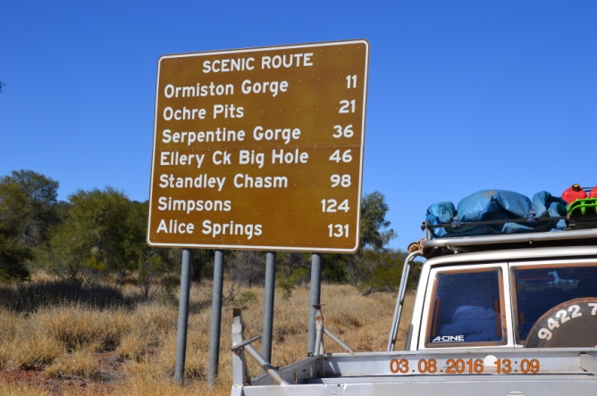
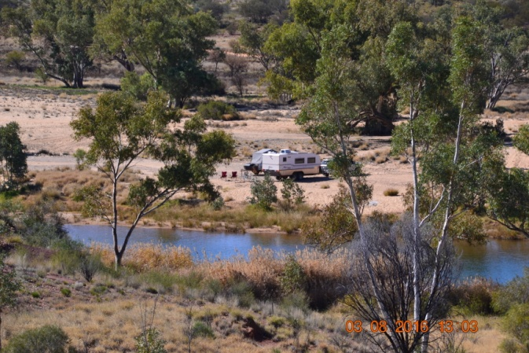

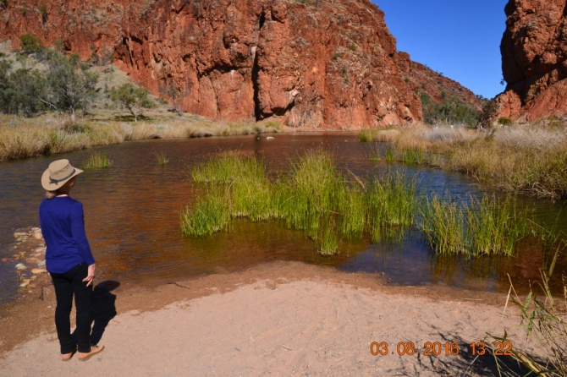
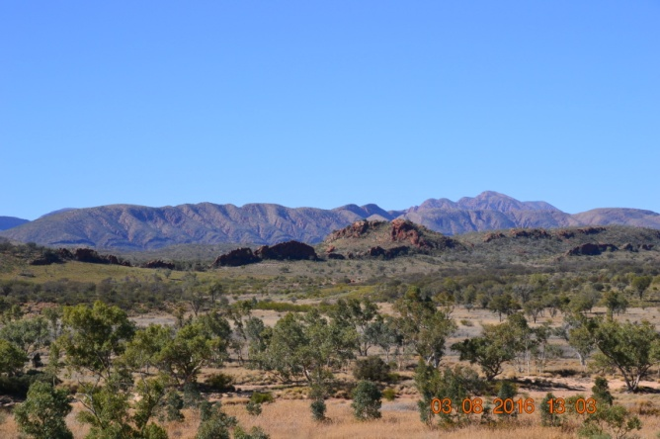
Next Stop, Ormiston Gorge, where we walked in to the base of the gorge.
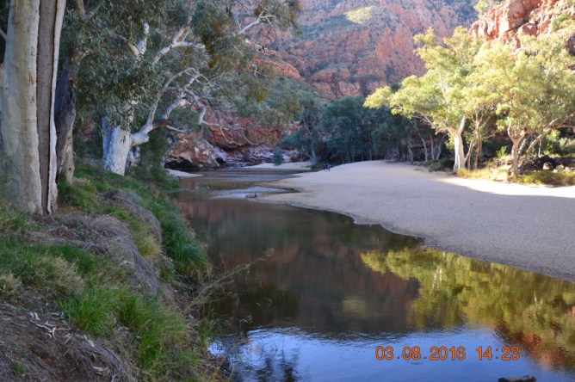
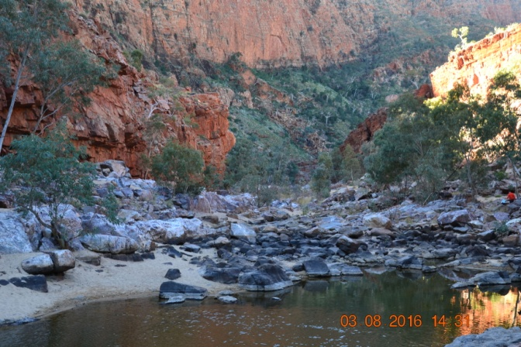
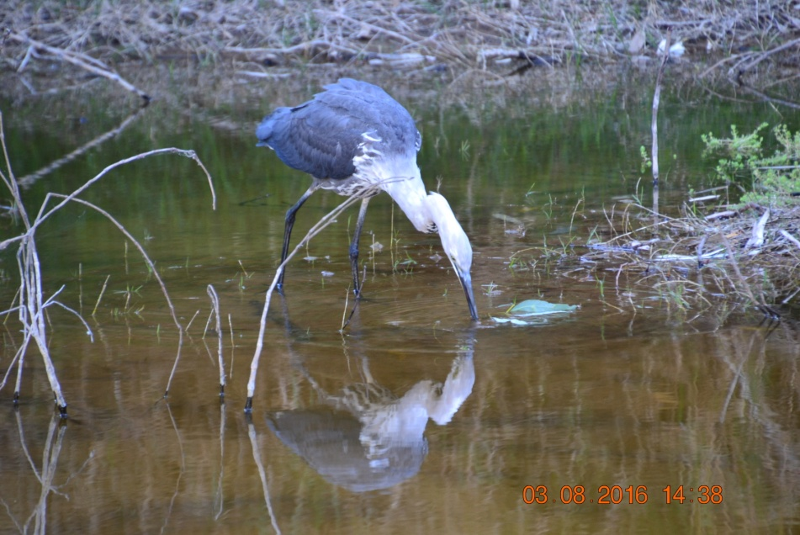

Then it was continue through the West MacDonnell Ranges as we made our way to Alice Springs.
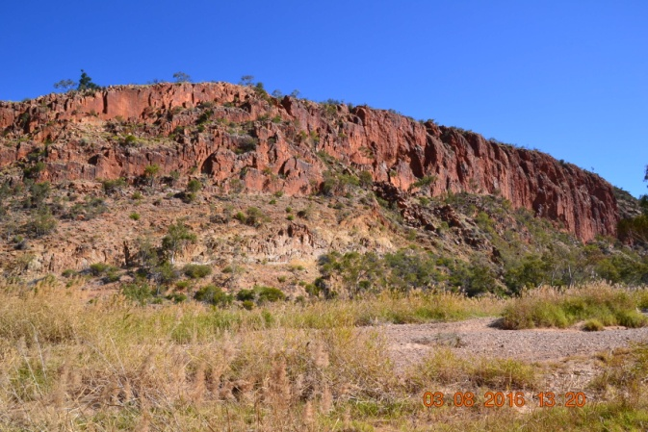
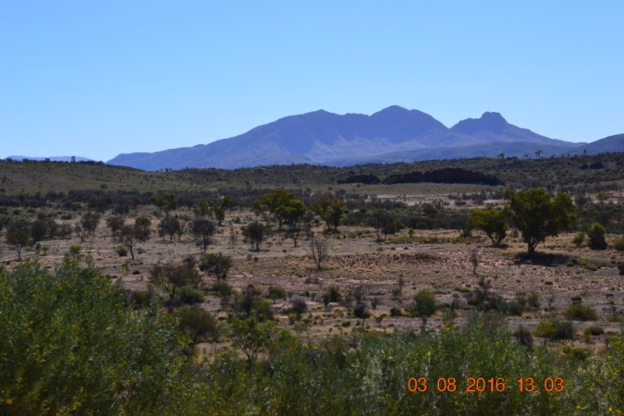

Day 8 - Alice Springs

Having covered nearly 3000Kms at this stage, most of it over rough roads, we were happy to take a break, stock up on provisions and attend to small maintenance tasks. We were happy to stay in a well secured facility which even had tyre spikes to prevent unauthorised entry. Several groups of yelling and unruly "locals" and other antisocial scenes didn't impress much. So, mainly a domestic day and getting ready for the next stage of the trip. Weather still fine but very cold wind still prevailed, and again bitterly cold the following morning when packing up to leave.

Days 9&10 - Alice Springs to Coober Pedy 708Kms

Day 9 saw us do a solid haul down the Stuart Highway to Coober Pedy. A fairly dull trip through predominantly flat country. CP was our stopping off point before embarking on the trip through to lake Eyre and the Flinders Ranges. It proved to be a memorable place itself, and we stayed an extra day to explore several local attractions.
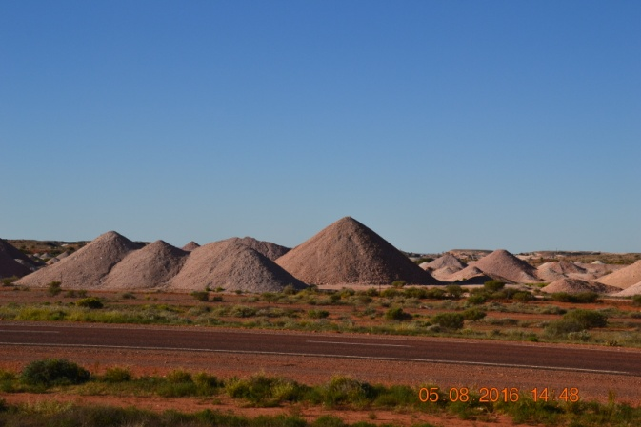
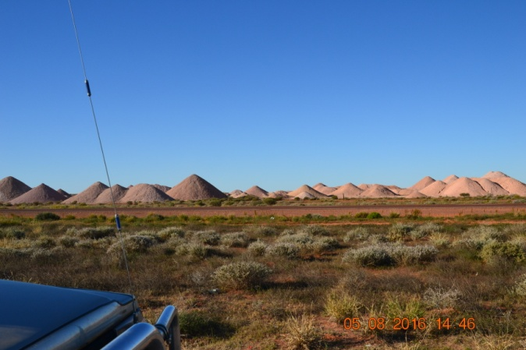
Approaching Coober Pedy is like coming into some weird lunar landscape, with tailing dumps from the opal mines everywhere. We subsequently found out that it is too dangerous to back-fill the mines, and the extracted tailings dug out in the search for opal deposits are just left in piles on the surface. A resident in the park we stayed in warned us about security, with theft by local children becoming an epidemic. Lock it up or lose it was the message. Sad but true.

Coober Pedy has evolved as a result of millions of years of nature's work. Once an ancient sea bed, dead animals that have become fossilised over great lengths of time then have become mineralised where water has been able to penetrate down faults in the land, carrying silica and other minerals that have gradually replaced the bone structures of dead creatures, creating opal deposits. These faults are called slides, and can be detected by miners using divining rods in the same way water diviners search for water. It is by following these slides underground that miners hope to find opal deposits. Not all slides result in deposits, it is not an exact science, but the absence of slides means no opal deposits will be present.
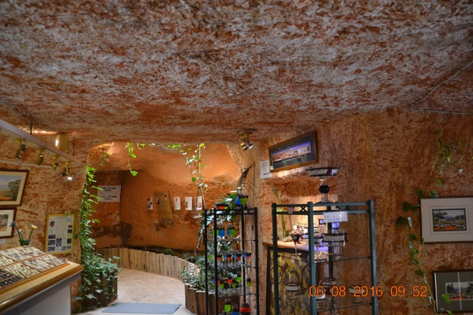
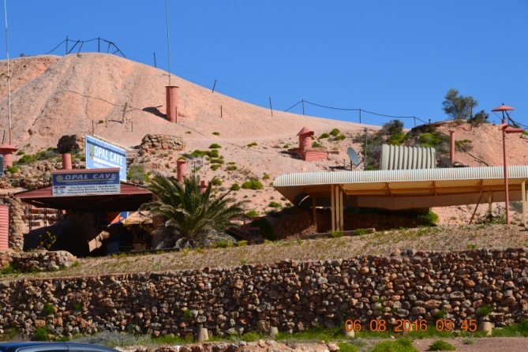
Probably half of Coober Pedy is underground, and it was to us one of the strangest places we have ever visited. We took the opportunity to visit various underground attractions, stores that sell opals made into jewellery, and did a tour of a working mine which was fascinating. Ruth and I were lucky to be the only people doing that particular tour, and we had the guide to ourselves, allowing a much more in-depth discussion on mining methods, how opals are found, how material is extracted from underground and so on.
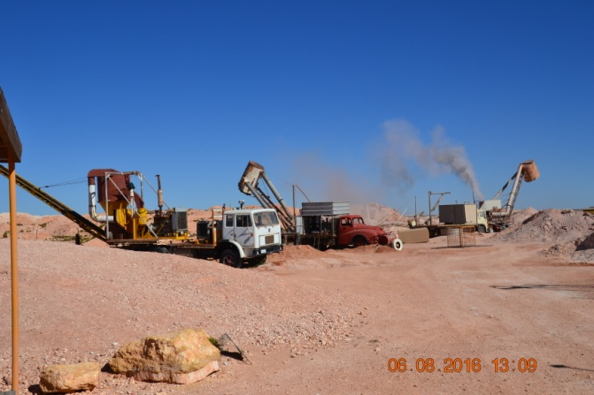
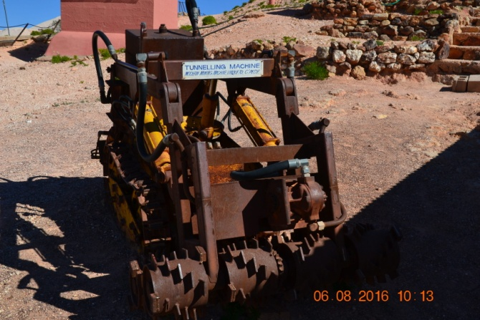
Miners work in darkness, usually pairs, one working a small tunnelling machine and the other looking carefully with an ultraviolet light for any signs of opal as they dig. If they strike opal the tunnelling machine makes very different sounds and has to be shut down quickly to avoid damaging the deposit, which is then extracted by hand. The tailings are taken to the surface by very powerful diesel engine driven extractors mounted on trucks which literally suck up the dust and rocks from underground, depositing it all in piles on the surface.
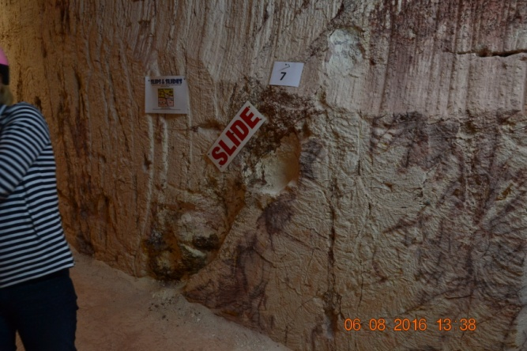
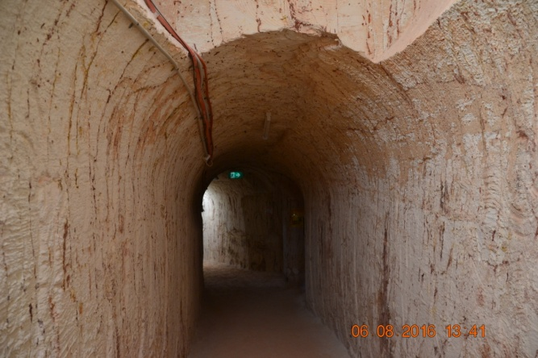
A lot of what is found is referred to as potch, opal that lacks colour and does not reflect light, and has no value. We dug out some rocks and found traces of opal in them, but didn't strike it rich. Potch, (a miner's swear word)!
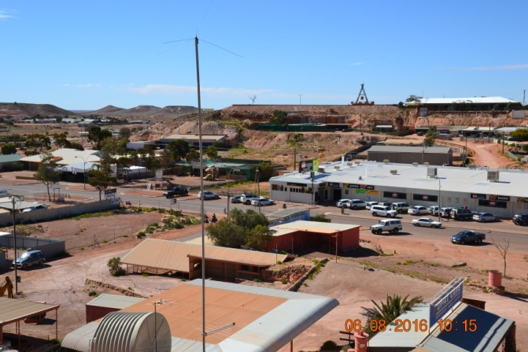
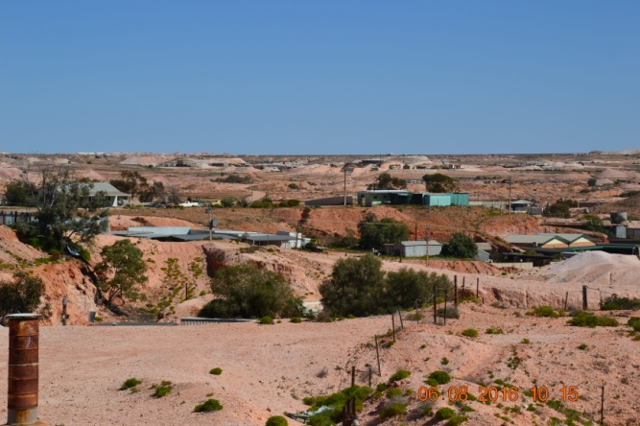

Days 11 to 14 - Coober Pedy to Willow Springs Station 873Kms

This was the section of the trip that took us in to William Creek and the Oodnadatta Track, around the southern end of Lake Eyre, and on into the Flinders Ranges. We passed through Marree on the way to an overnight stay in Leigh Creek, then on to Arkaroola Village, and then down to Willow Springs Station.

Day 11 - Coober Pedy to Leigh Creek 493Kms

Back on to the unsealed roads as soon as we left CP, the first part of the trip wasn't too bad along the William Creek Rd, but evidence of extensive road damage in recent rains became obvious as we travelled, with sections reduced to one lane passing huge bog holes. We soon left the opal mines behind, and crossed mostly flat country, with evidence of wildflowers starting to emerge, something that had been largely absent from previous sections of the trip. The William Creek Rd passes through Anna Creek Station, the largest working cattle station in the world, owned by the Kidman empire, but up for sale at the moment. You cross many cattle grids as you travel, but we were fortunate not to have any encounters with straying stock on the road. Lots of vehicle tyre ruts as further evidence of the recent weather, we travelled with tyre pressures lowered and travel speeds again kept to around 70Km/h or less in very rough spots.
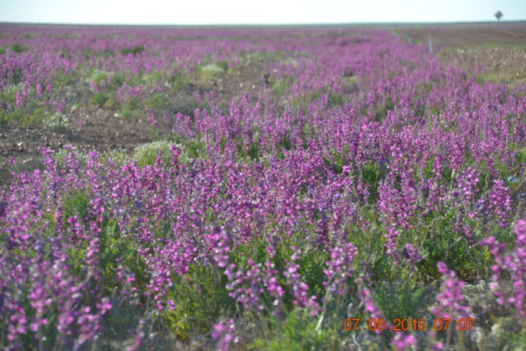
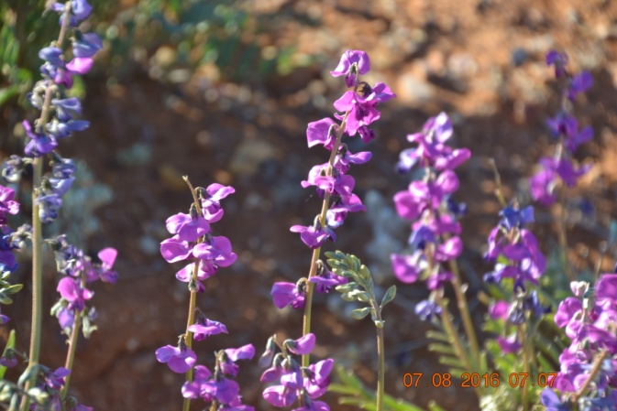
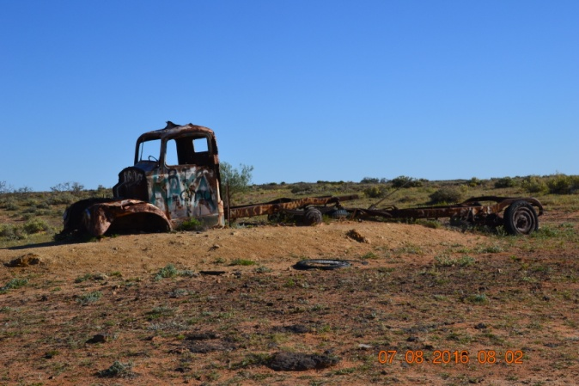
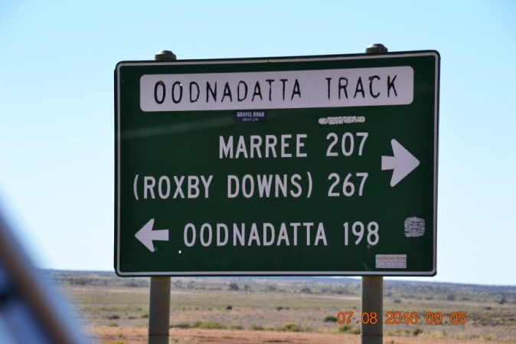
The William Creek Rd joins the Oodnadatta Track at William Creek, and we encountered one of those outback gems of a country pub there. It's an iconic little place, very rustic in construction, with cards of many visitors stuck to the roof inside.
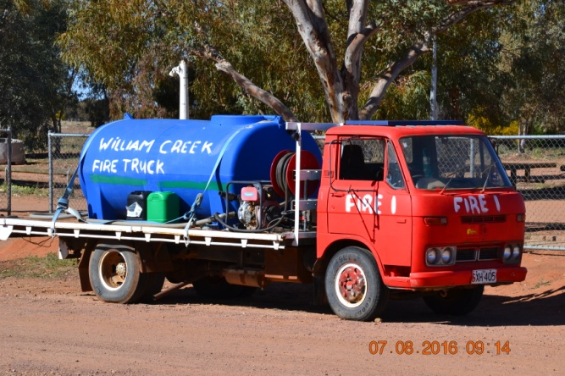
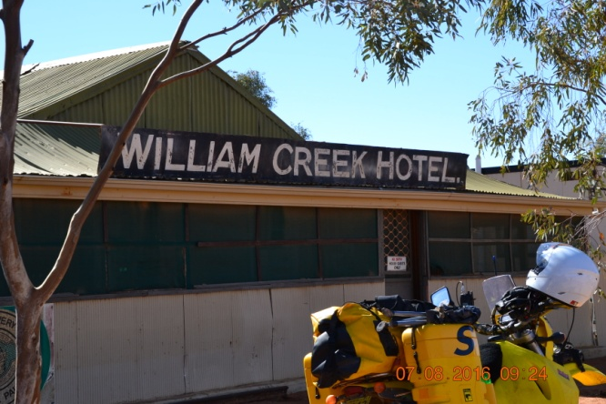

We decided not to take a flight over Lake Eyre from here, as reports from other travellers had said the water on its way down the Diamantina River from Queensland was still about a month away, and lake levels were still low. That and over $500 for the pair of us to take a one hour flight made it an easy decision.

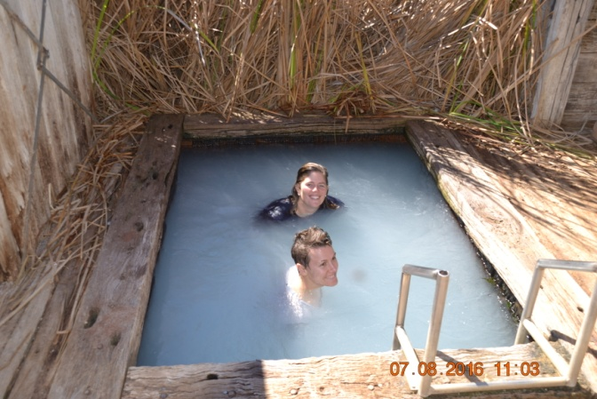
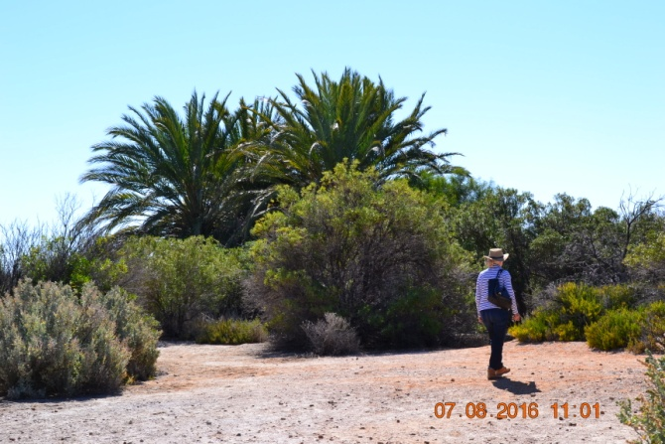
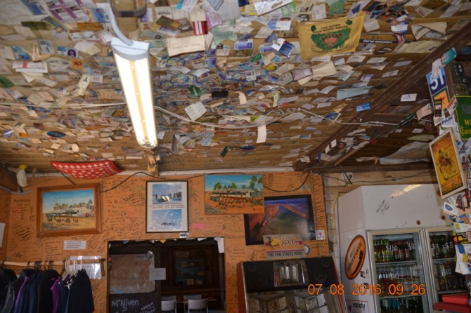
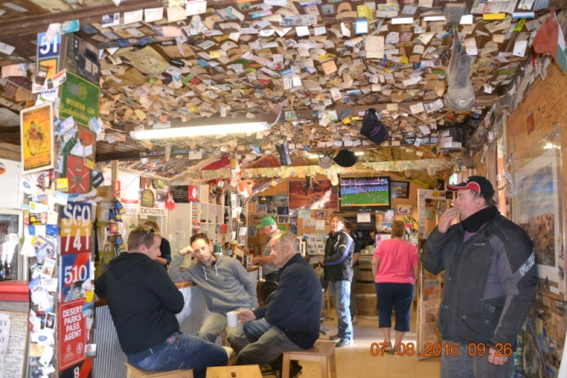
After topping up on fuel and having a coffee at the pub we continued on down the Oodnadatta Track. The track was built to support the central Australian railway, the original route of the Ghan, and along its length there are natural springs, ruins of railway sidings and the remains of old railway bridges to be seen.
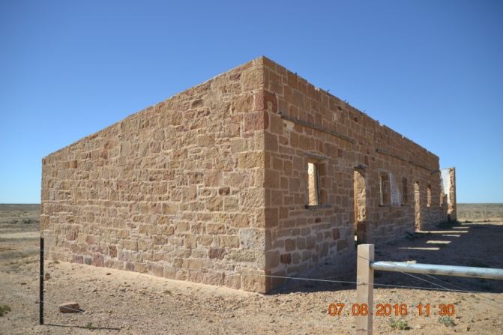
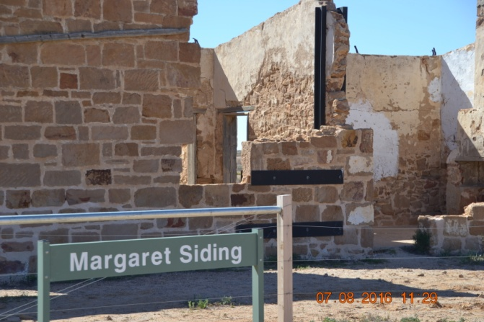
We stopped at Coward Springs where there is a natural spring you can soak in, and also stopped at one of the sidings from the old railway.
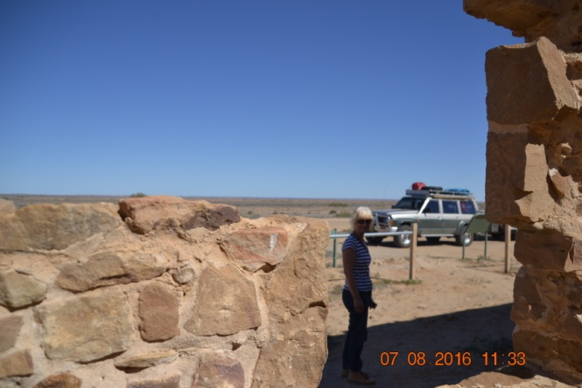
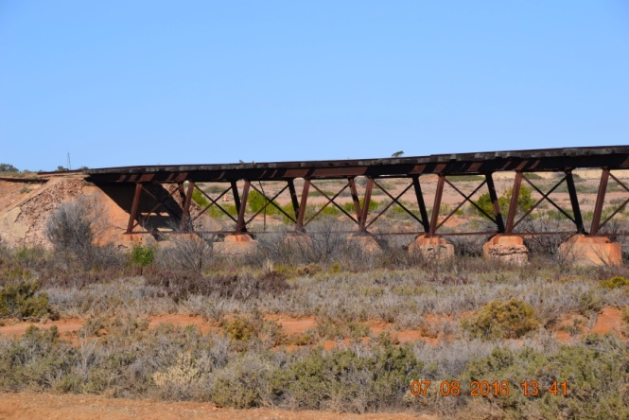
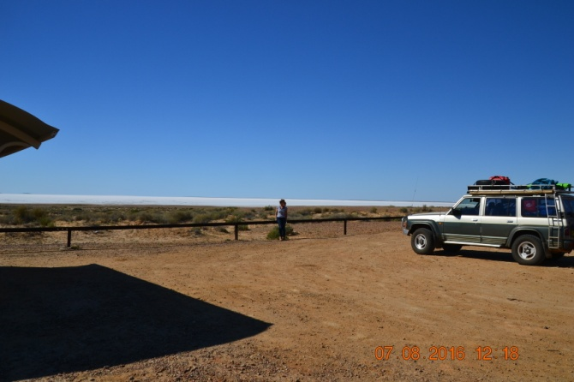
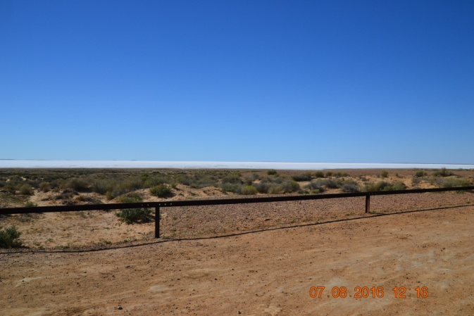
Just after Coward Springs you cross the bottom of Lake Eyre. It was completely dry in the southern lake, just a giant salt pan as far as the eye could see. One day we will get so see it with plenty of water in it. Just not this time.
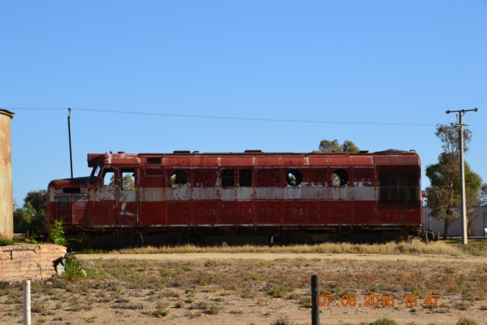
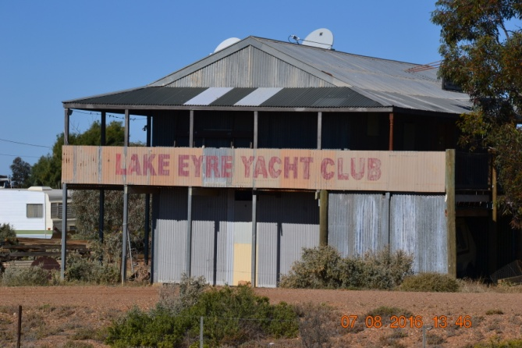
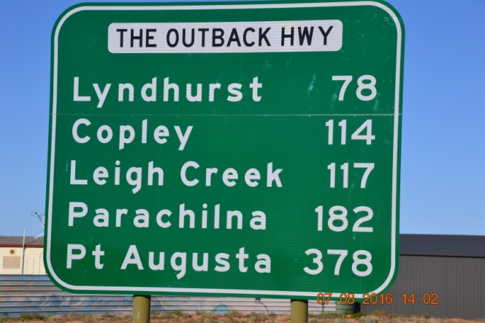
The Oodnadatta track ends at Marree at the southern end. Road very rough and water damaged in places. The unsealed road continues south before reaching the seal just before Leigh Creek. A number of iconic outback tracks intersect this route, the Birdsville Track starts at Marree, and the Strzelecki Track starts at Lyndhurst, a bit further south.

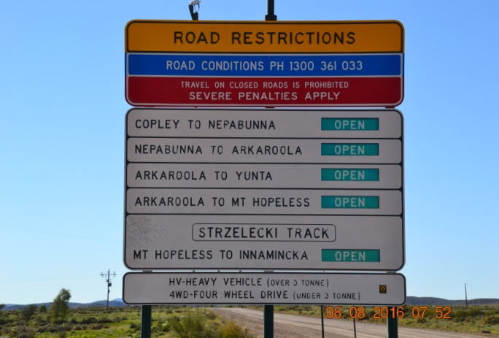
Day 12 - Leigh Creek to Arkaroola Village 163Kms

This may not seem very far, but took quite a while to cover the ground. We now entered the Flinders Ranges proper, and made our way up to the northern end in the Vulkathunha-Gammon Ranges National Park in the North Flinders Range. Arkaroola Village is a sanctuary area with many areas of interest and tracks to explore there.

The road winds through the ranges, is very rough in places, and is punctuated by many crests followed by floodways or washouts, and you cross many cattle grids too.
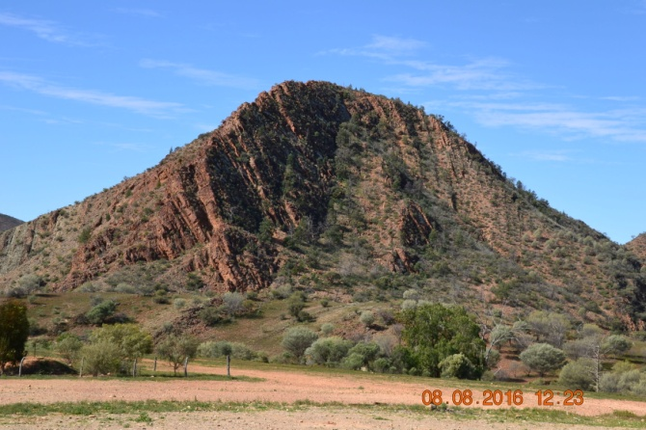
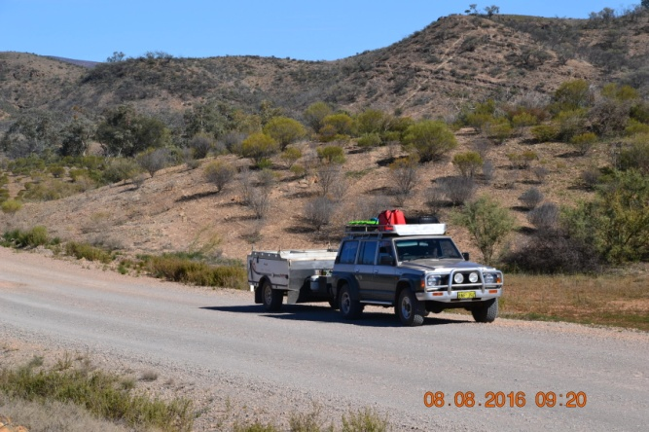
The hills and mountains are very rugged in places, with similar structure to some of the Pilbara and to the West MacDonnells too. Lower tyre pressures and slow travel pace is the order of the day. It is an attractive trip, very scenic and interesting country. It was on this road we had the two mechanical issues referred to previously, the LPG gas tank shroud breaking off its mounts, and the top of the air box coming loose, both of which were solved relatively easily.

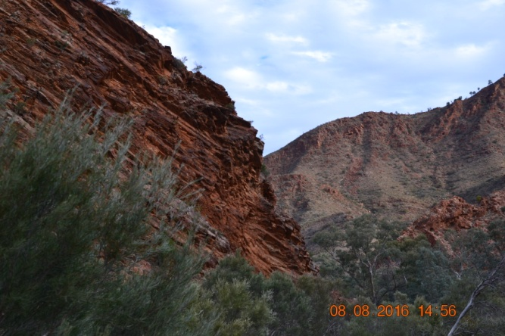
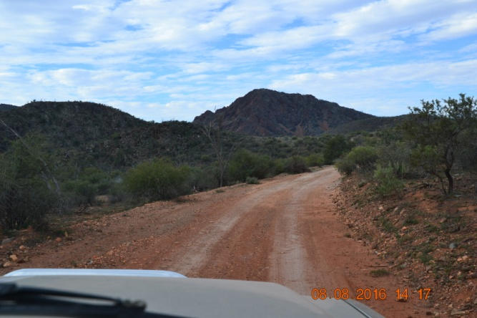
I spoke to the mechanic at Arkaroola, and he had a look under the Patrol at the LPG tank. My original idea was to drill some holes in the shroud and simply wire it in place to get us back to Perth. He suggested that what we had done on the road was fine, and he added a pair of old occy straps to supplement the tie downs we had used to secure it. I didn't recognise who I had been speaking to until later when Ruth and I were driving one of the 4WD tracks to one of the local points of interest.

Silly me, it dawned on that it was Doug Sprigg. Doug and his sister Marg now run Arkaroola Village after their parents died. They are the son and daughter of Reg Sprigg, the explorer who made the first vehicle crossing of the Simpson Desert in a short wheelbase G60 Patrol back in 1962, a trip re-enacted for its 50th anniversary in 2012 and shown on Pat Callinan's 4x4 Adventures. In 1962 Reg and his wife and the two kids travelled across the Simpson squeezed into the front bench seat of the G60 on the original journey. No tracks back then.

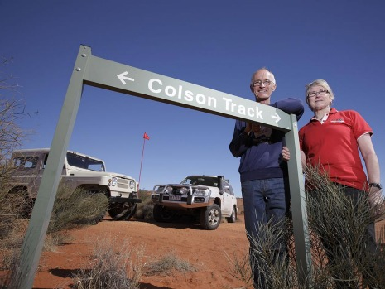
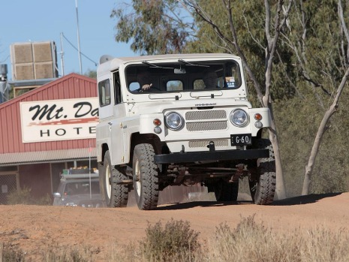
The G60 used for the re-enactment Doug and Marg Sprigg

Fortunately I had the chance to catch up with Doug again that evening while we were having a drink in the resort bar, and we had a very animated discussion about his experience on the re-enactment trip. A very amiable and likable character, and a great guy to talk to. He recounted that the G60 they used for the 2012 trip was not the original vehicle (it couldn't be found), but it was an identical SWB model that had been found in Tasmania that had only 60,000 miles on the clock. Nissan had it fully restored for the journey, and Doug reminded me of some of the early vehicles I owned when he described using its three speed gearbox and having to double de-clutch often when changing gears. Brought back memories. I recall Pat Callinan describing Doug on his TV show as one of the best sand drivers he had met in Australia. A man with obvious mechanical skill and sympathy in the way he drove. Great to meet someone like that.

Days 13&14 - Arkaroola to Willow Springs Station 309Kms

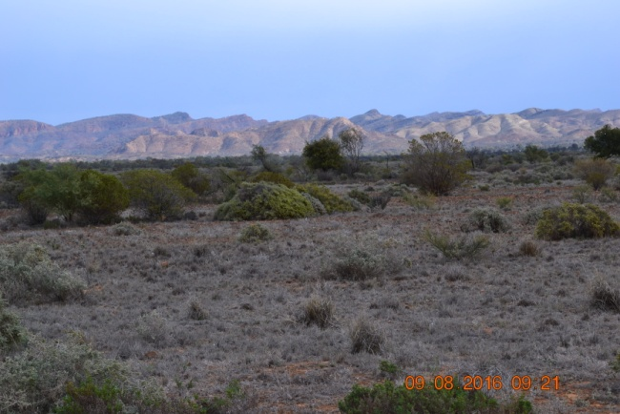
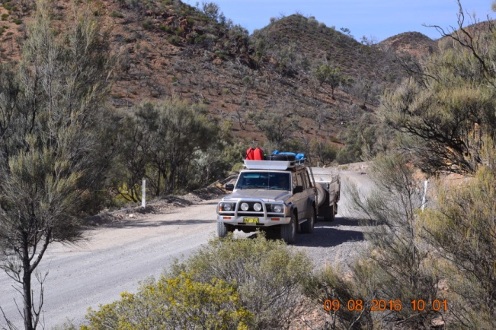
The first part of the trip retraced the road taken the previous day through the Northern Flinders Range, and then skirted the Ranges as we made progress south before turning back into the mountains again as we made our way to the old mining town of Blinman.
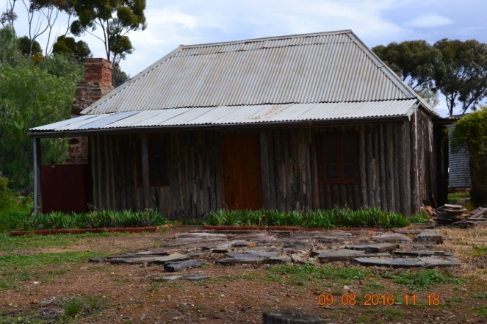
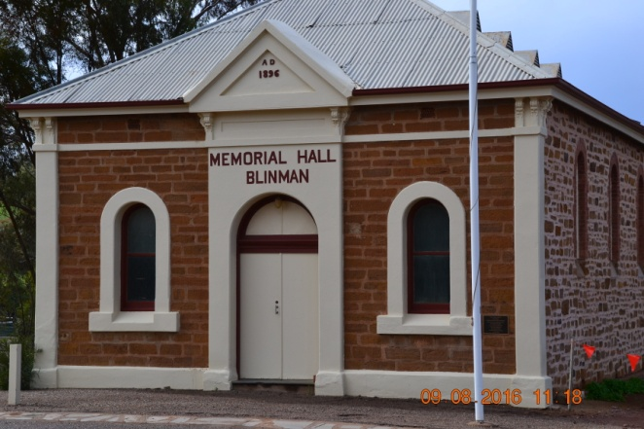
From there on we had sealed roads through the Flinders Ranges National Park to Willow Springs Station which is at the southern end of the park. A typical journey through the Flinders, unsealed road for most of the way, rough in places, lots of crests, floodways and cattle grids with the road then winding through lovely hills when we were back in the ranges. We enjoyed the drive.
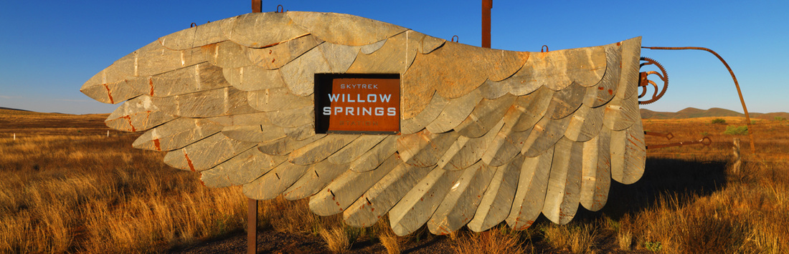
Willow Springs Station is a working sheep and cattle station which has developed a tourism side of the business that attracts 4WD drivers to its renowned Skytrek tour, which we decided to stay and do. It was a great days driving, although I think it took Ruth a full day to get colour back into her white knuckles after the last section which was much more testing than the first part of the trip.
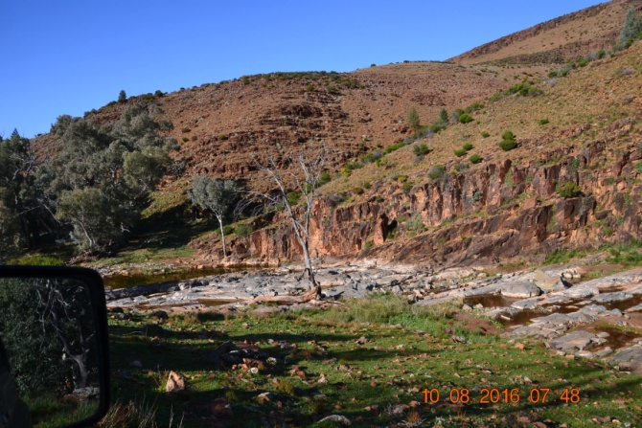
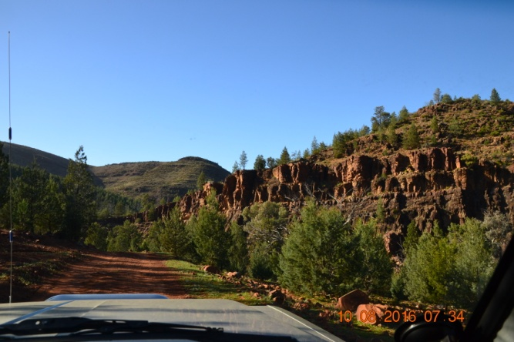
The tour starts at the homestead, and for a while works its way through the lower part of the property, with many points of interest along the way. Every point is numbered with a full description of the area associated with the number provided in the booklet you get, along with the key that opens access to the tough part of the tour.
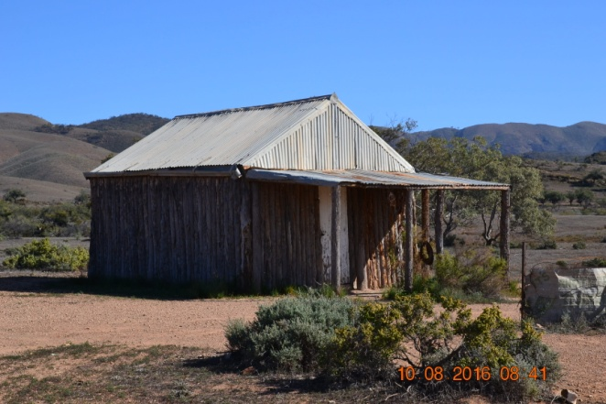
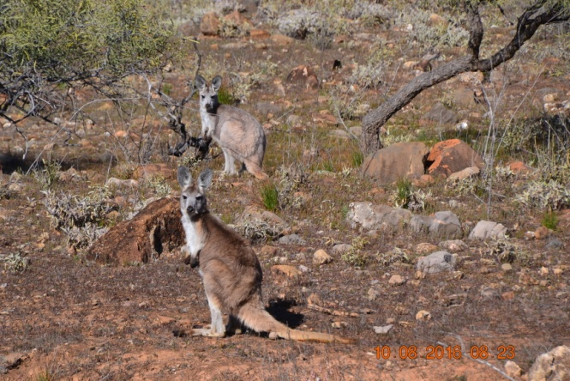
There is an association with the Nissan Patrol Club, who helped restore the old wooden shepherds cottage that you encounter early in the journey.
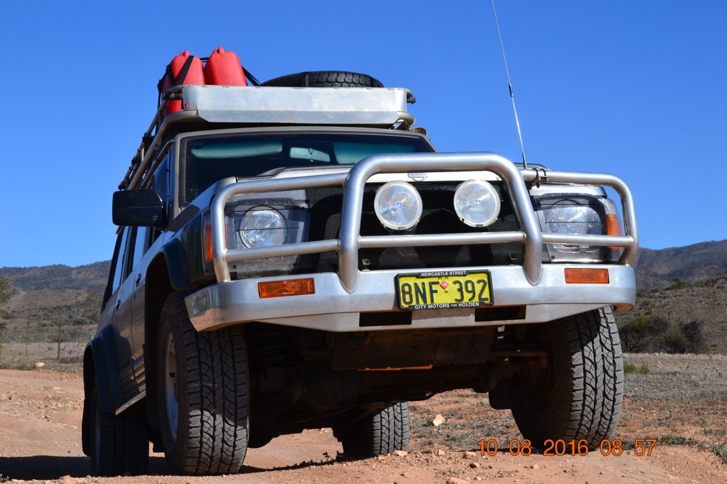
The Patrol worked brilliantly through the whole trip. The first part of the trip was easily driven in high range. The entire package of tyres, suspension, gearing, lockers etc all combined to give us a great ride over everything the trip threw at us.
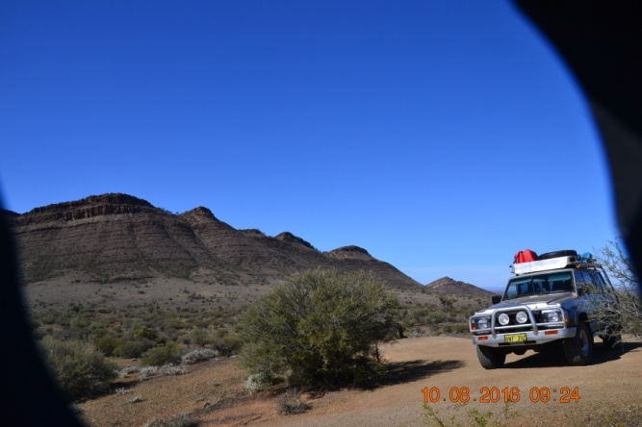
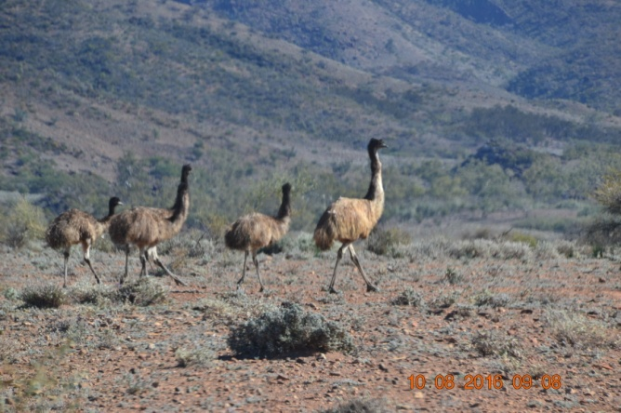
The rough and very steep and rocky parts of the trip not only tested traction and gearing, but also arrival and departure angles as well. On several occasions I thought the bull bar would scrape into the very steep entry points at the bottom of the descents that immediately turned into very sharp ascents, but not a touch, and no scrapes at the rear either. The photos don't really do justice to what we encountered, but hope they give some idea.
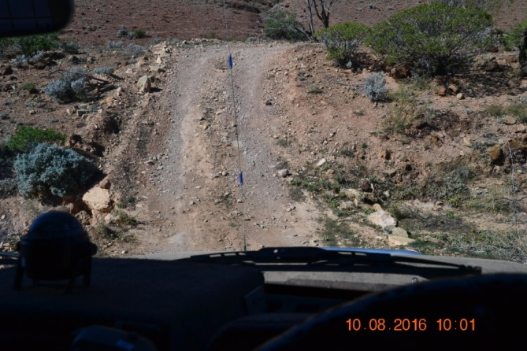
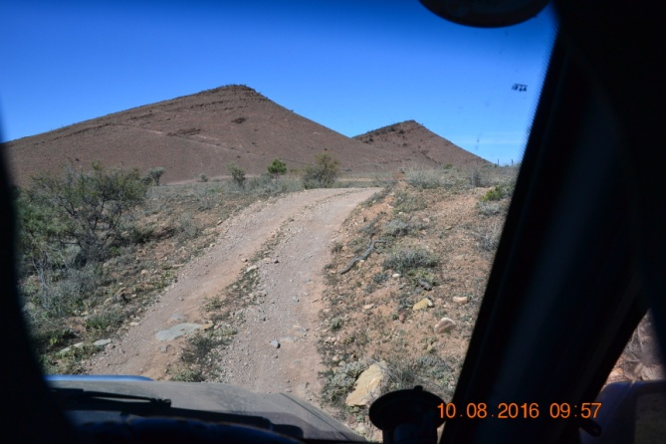
Ruth shot some videos with her phone and it is interesting to hear her comments on some of them (NFP). It is slow going. We stopped briefly to tick off each point along the way or take photographs, but it took a total of 7 hours to cover the 79Kms of the tour. A full-on day of four wheeling that we felt was a great trip. To be able to drive over ground like that with absolutely no wheel spin really brought home to me how good front lockers are. Equally, to be able to descend extremely steep terrain in first low range with little or no brake application was also good. I tried by comparison one descent in 2nd low range to compare the gearing, and had to do lots of brake applications. The crawler gear was the way to go both up and down in the steep sections.
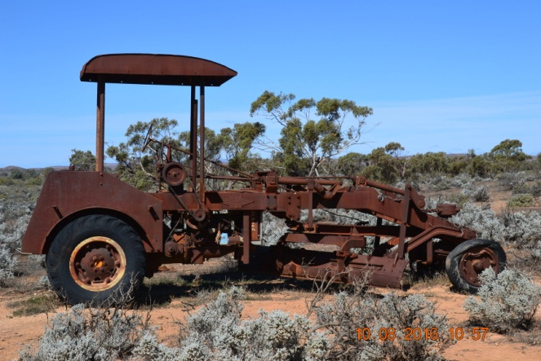
We thought at one stage that Len Beadell might have been to Willow Springs before he tackled the Gunbarrel. During the tour you come across an old grader that was used to make early roads around the Willow Springs and Blinman area that is clearly a generation before the old grader now caged at the Giles Weather Station.

We had several encounters with wildlife on the tour, different from the animals that bounded past us at Arkaroola. Up there was yellow footed wallabies with yellow and black striped tails, whereas Willow Springs was typically grey or red kangaroos or groups of emus. Also very different terrain, with ochre pits and all sorts of other variety.
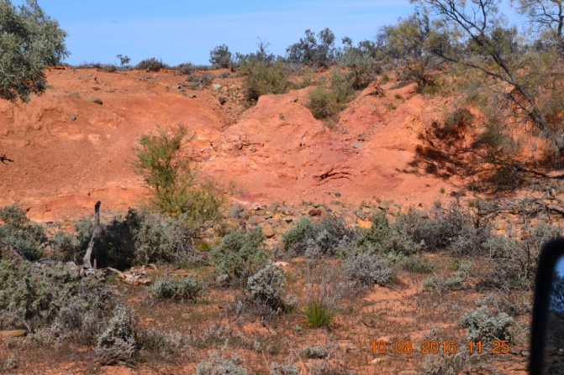
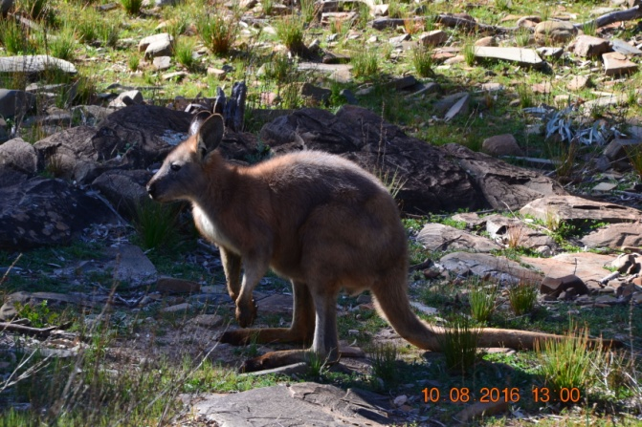
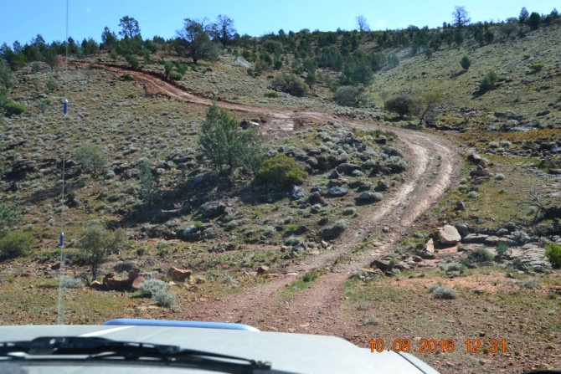
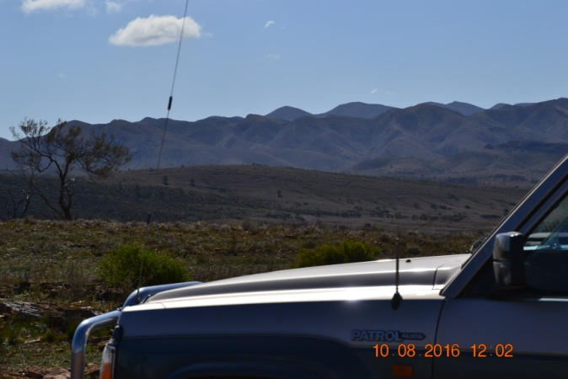
The views from the elevated parts of the trip are at times spectacular, as well as from the nearby Stokes Hill Lookout that gives views of the Flinders Ranges as far as the eye can see.
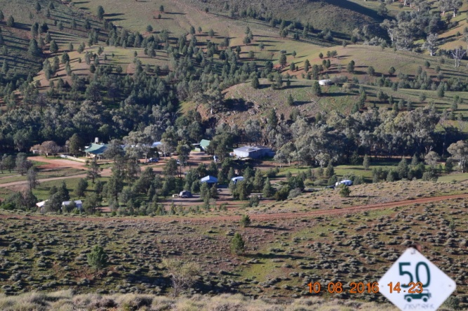
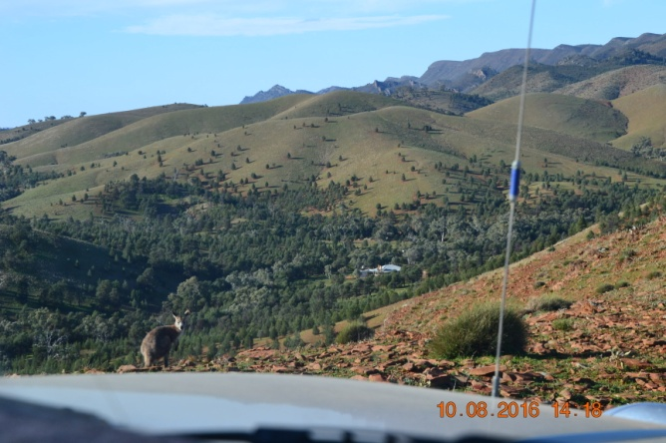
Towards the end of the tour you arrive at an elevated position that gives views down over the homestead. A great day that we will remember for a long time.

Days 15 to 17 - Willow Springs Station back to Perth 2639Kms

After that it was time to depart the Flinders Ranges and simply knock off the Kms on the long road back to Perth. What amused me in parts of South Australia was warning signs saying things like "Tired Drivers Die" or similar, and then they go and make boring straight roads that do a pretty good job of putting you off to sleep if you allow your concentration to lapse. If I had a black texta with me I am sure I could have made comments along the lines of cause and effect if I had wanted to deface any of their signs.

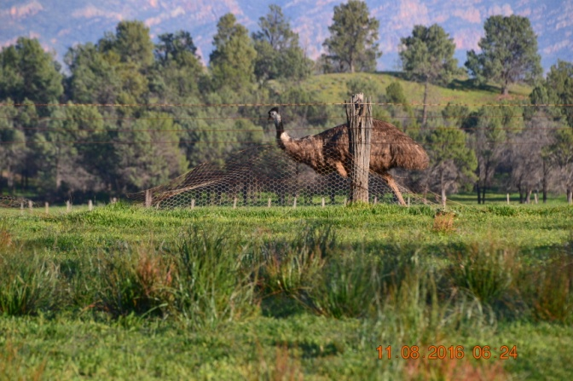
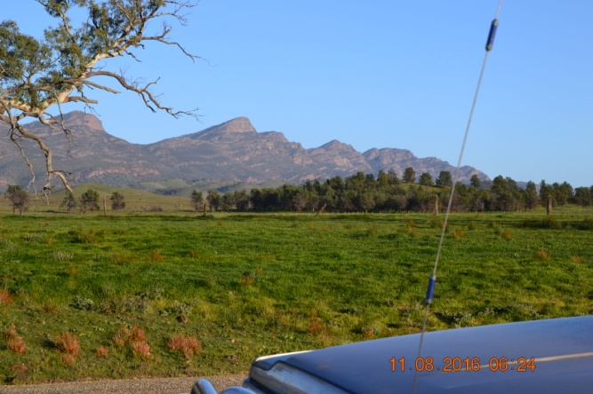
The trip took us towards the southern end of the Flinders (although they continue well south of PA), through Quorn and down to Port Augusta where it was fuel up and make our way to the Eyre Highway that would carry us across the Nullarbor once we got that far. On day 15 we covered 734Kms, getting as far as Penong, still some distance shy of the WA border.

On day 16 we covered a further 786 Kms, getting as far as Caiguna that evening. The first thing of interest was "Checkpoint Charlie" as Ruth called it, the quarantine station at the WA border, where we encountered "Attila the Hen." Talk about give a man (or in this case a woman) a uniform! The Gestapo insisted on going through everything including making us open the camper trailer so she could go through the fridge in there, even though we only had a few items mainly in jars in it. I think in order to justify her existence she confiscated a small quantity of fruit salad in a container, even though the website that deals with border quarantine requirements stated it was OK to take prepared fruit salad through, only raw fruit was unacceptable. If Australia put a fraction of the effort into its national bio-security that it puts into harassing people carrying perfectly good produce across state borders we would be a lot better off. The whole exercise was just ridiculous.

The main attraction on day 16 was visiting the Head of the Bight and watching the whales that gather there. We first visited there on our round Australia Trip when the whales were much more active then than they were on this occasion.

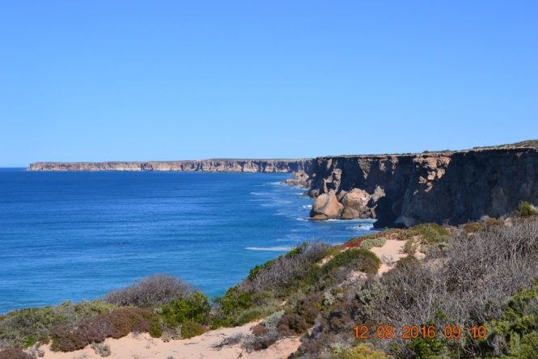
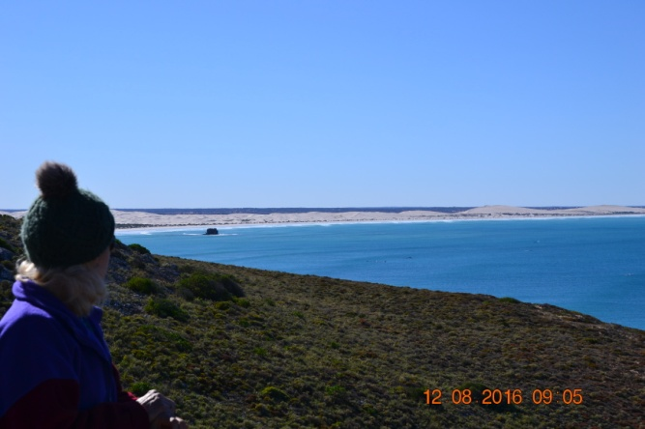

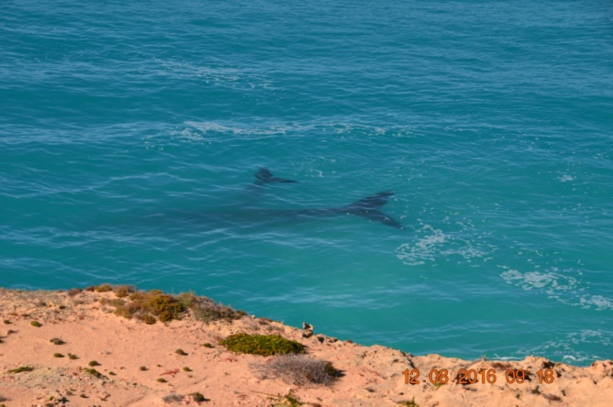
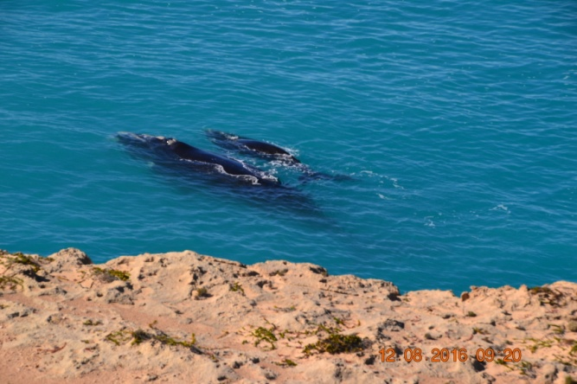
There were several mothers with calves there, and they all appeared to be just lazily swimming in the swells that roll in there from the Southern Ocean. The colour of the ocean and the sight of cliffs that go for miles is also a great sight.
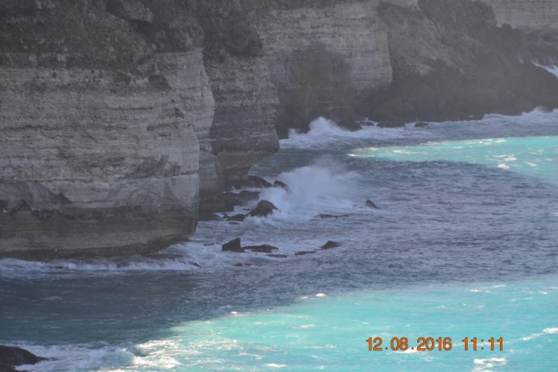
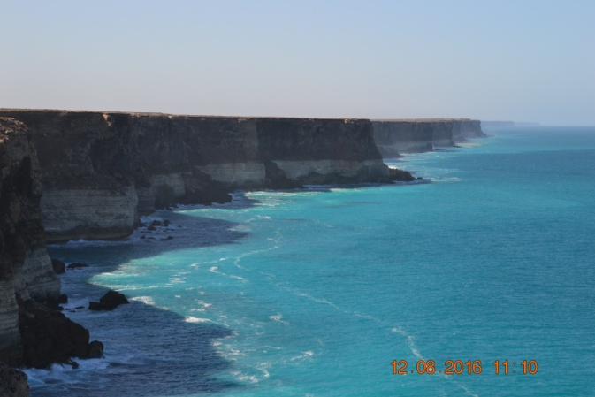
The cliffs at the Head of the Bight and the Zuytdorp Cliffs north of Kalbarri are the two huge barriers sea kayakers have to overcome when circumnavigating Australia, both with unbroken cliff lines that extend well over 100Kms. Paddling them unsupported is considered the Mount Everest of sea kayaking, very few have achieved it.

Day 17 Caiguna to Perth - 1115Kms. This was a day of determination to get back to Perth in one day rather than have to stop another night within a short distance of home. I figured we would enjoy a bit of a sleep in on the Sunday and a more leisurely start to the process of unpacking and starting the big clean up if we made it home in one day, the proviso always being that I felt Ok to continue driving. To cover that distance in a day towing is a big day, and involved several hours of night driving, greatly assisted by the uprated headlights fitted before we left.

All went well and we rolled into Perth around 11.00pm and gratefully fell into bed, leaving the truck and trailer parked on the lawn. Worry about that in the morning. Odometer reading at the end of the trip was 7245Kms.

In all a great trip, with very little in the way of any problems, and many great memories to treasure. We love travelling when we get the opportunity. I hope it won't be too long before we consider the next big adventure.

